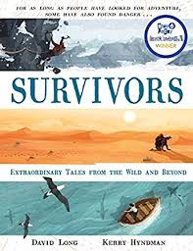
- Read page 35, ‘The men who shared a sandwich on the seabed,’ up to page 38, ‘….the two men were in the dark and on their own.’
- What was the Pisces 111?
- At the top of page 36, which word tells us that the two men are not going to have a normal shift?
- What makes the job the men do dangerous?
- How had Mallinson prepared for this particular shift?
- What was different about this particular shift for Chapman?
- What safety measures had been put into place to ensure the shift went smoothly for the men?
- What actions did the men take when they realised they were sinking?
- Why do you think these actions were important?
10.After the men came to rest on the seabed, what actions do you think they would take to ensure their survival?

