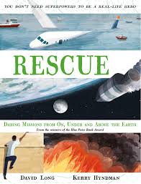
- Read from page 136, ‘There were several problems with this plan…’ to the bottom of page 137.
- What were the problems with the initial plan which was to climb through a hatch into the Lunar Module?
- There were an incredible 400 000 men and women involved in the mission. Do you think everybody involved was important? Can you give examples of 6 different jobs and explain why they were important?
- If you were one of the 400 000 people on the ground, what would you have done or tried to do?
- Do you think you could do one of these jobs? Indeed, would you like to? What skills would you be able to bring?
- Look at the picture on pages 138 and 139, exactly what part of the rescue is the picture representing?

