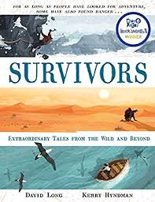

Read from the bottom of page 53, ‘He was fit and practically minded…’
to the end of the story.
Imagine that a film is going to be made about Poon Lim’s story. You are the film director and you desperately need to get actors and a film crew on board.
Summarise the story in an exciting way for them so they wouldn’t be able to resist working for you.

