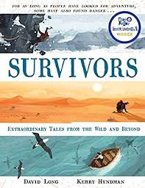
- Read the remainder of, ‘The snowboarder who took a deadly wrong turn.’
- How did you feel when you read the final part of the adventure? Why?
- Which words/phrases does the author use to build tension when the helicopter arrived? Explain.
- The author says, ‘…we can never be sure…’ on page 106. What is the author unsure of? What do you think would have happened? Why?
- If you had the opportunity to interview Eric now, what questions would you ask him?

