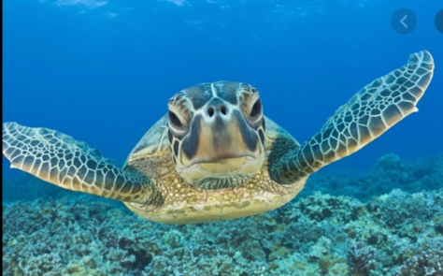
SEA TURTLES

What sea animals live for up to 100 years?

Sea turtles have roamed around the Earth’s oceans for the last 110 million years.

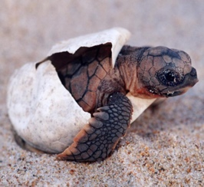
They come to the surface when they are between 10 to 50 years old to lay their eggs.

There are lots more interesting facts about sea turtles that you need to know!

FOOD
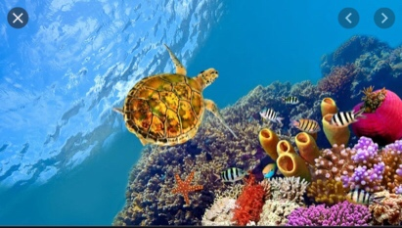

Sea turtles love to eat coral, sea grass and their favourite food is jellyfish.

HABITAT

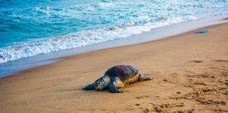
They nest on beaches.

Pollution is affecting see turtles a lot save the turtles.

