One Wasn't Square

Age 7 to 11

Mrs Morgan, the class's teacher, pinned numbers onto the backs of three children: Mona, Bob and Jamie.
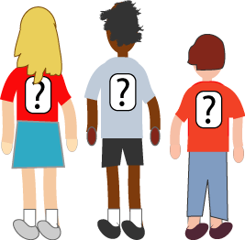
"Now", she said, "Those three numbers add to a special kind of number. What is it?"
Michael put his hand up.
"It's a square number", he answered.
"Correct", smiled Mrs Morgan.
"Oh!" exclaimed Mona, "The two numbers I can see also add to a square!"
"And me!" called out Bob, "The two numbers I can see add to a square too!"
"Oh dear", said Jamie disappointedly, "the two numbers I can see don't add to a square! It's either 5 too little or 6 too big!"
What numbers did the three children have on their backs?

