Self Isolation Work
Week Beginning: 05/10/2020
Year Group: Reception

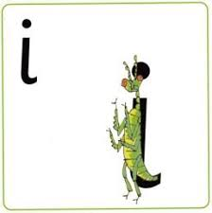
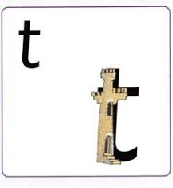
Phonics:
This weeks sounds: t and i
t: Up the tower, down the tower, pencils off, wiggle your bottom, across the tower
i: up the insect, down the insect, pencils off, wiggle your bottom, and a dot for his head
Practise saying the rhyme, writing the letter in different ways- magic finger, in a bowl of rice, chalks, pens, tablet screen
Can you find things beginning with these letters?- draw them! Can you find these letters around the house, in your book, is this letter in your name?
Using the letters below, make some CVC words to practise Freddy Fingers!
m a s d t i
Maths:
This weeks mathematics focus: Three
Number blocks video: https://www.bbc.co.uk/iplayer/episode/b08bzgxx/numberblocks-series-1-three
In class,w e watch the video daily at the start of each session and then have a discussion about what they saw in the video!

Writing:
Can you draw the following things and label them:

M-u-m d-a-d d-o-g c-a-t p-i-n m-a-t l-e-g

