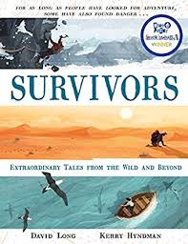
- Read P.70, ‘The trapper who grappled with a grizzly,’ up to page 72 ‘…tattered clothes and into the ground.’
- Can you think of synonyms for embarking (bottom of page 70)?
- Why do you think the author describes ‘life in the wilderness as brutal’ (end of first paragraph on page 71)?
- Why do you think Hugh Glass decided to join the expedition?
- What does the author mean by ‘bleeding profusely’? Why did he choose to use the word ‘profusely’?
- Which part of the recount best describes a grizzly? Explain.
- How did it make you feel when you read about the bear attacking Hugh Glass? Why?

