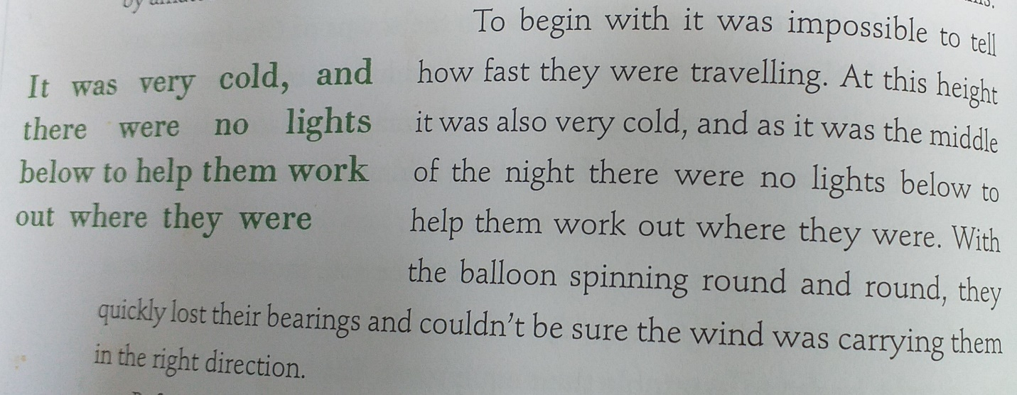
Read this passage.
Think of five questions you could ask about it.
Now answer your five questions.

