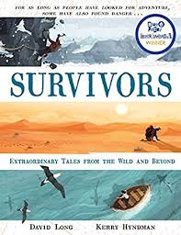
Look at the picture on page 150. Write a story about it.

