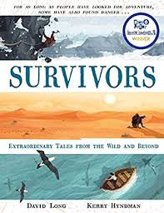
- Read from P.110, ‘There was no sign…’ up to the end of the story.
- What strategies did the men choose initially to get themselves out of their tricky situation?
- What do you think about the strategies the men chose? Can you explain why Benson would have been feeling the most anxious?
- How did he try to overcome his anxieties?
- Why do you think the men all tried to follow different routes to safety?
- What strategy would you have chosen to get to safety?
- What question would you ask Benson now?

