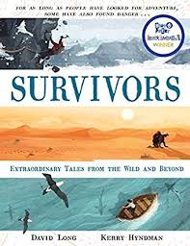
- Read from page 118, ‘The good news…’ to the end of the story.
- Imagine that you have the chance to talk to Anna. Write down the conversation you would have. Think carefully about what you would ask her and how she would respond.

