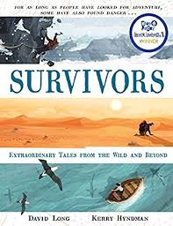
- Read from the bottom of page 14, ‘Alone in the endless blizzard…’ to the end.
- Watch this clip about a journey to Mawson’s huts. https://www.youtube.com/watch?v=tJKNcjlUxUQ
- In what way did Mawson and his men lay the foundations for the discovery of Antarctica?
- Think about all the experiences that Mawson went through. How has it helped future explorers?

