Self Isolation Work
Week Beginning: 19/10/2020
Year Group: Reception

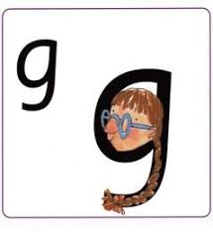
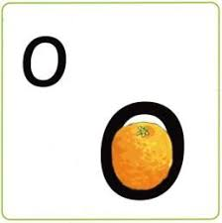
Phonics:
This weeks sounds: g and o
g: Up, round her face, down her hair and give her a curl!
o: Up, back around the orange and flick!
Practise saying the rhyme, writing the letter in different ways- magic finger, in a bowl of rice, chalks, pens, tablet screen
Can you find things beginning with these letters?- draw them! Can you find these letters around the house, in your book, is this letter in your name?
Using the letters below, make some CVC words to practise Freddy Fingers!
m a s d t i n p g o
Maths:
This weeks mathematics focus: 4
Number blocks video: https://www.bbc.co.uk/iplayer/episode/b08d61cv/numberblocks-series-1-four
In class, we watch the video daily at the start of each session and then have a discussion about what they saw in the video!
Back on the page you downloaded this document there are resources to aid in this weeks learning!

Writing:
Fine motor practise this week, see the attached sheet with autumn patterns to trace and copy.

We are also practising writing our names in cursive. Can you spot which letters are in your name and have a go at writing them- this can be done as big or as small as you like (gross or fine motor!)

