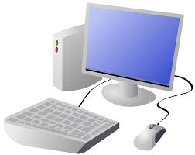
COMPUTING: CREATING MEDIA- Web Page Creation
KNOWLEDGE ORGANISER

Key Knowledge |  |  | Creating a Webpage
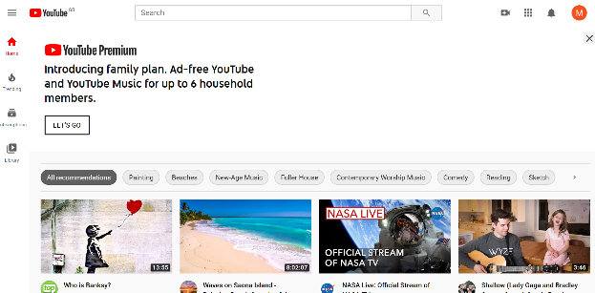  Web Page Creation  -A webpage is a hypertext document that is a part of the World Wide Web.  -Websites are a collection of webpages about the same topic. They can be found using browsers.  -Examples of websites are Amazon and YouTube. Webpages are the different pages on the websites.  -Websites are created for a chosen purpose, and with a particular audience in mind.  -They include navigation paths, and must adhere to copyright and fair use of media rules.  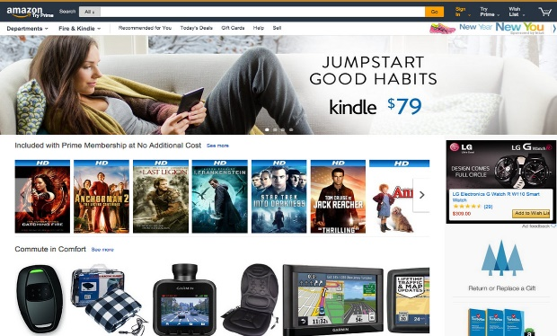 |  |  | Google Sites has been used in these examples, but lots of other web page creation software and apps are available, with similar tools and functions.
 |  |  | 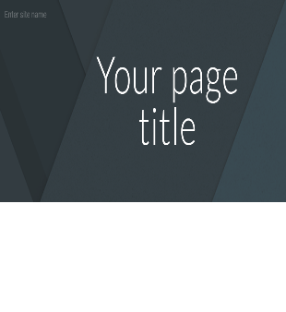  Setting Up: Click + to start a new website. Click on the top left to add a website name and the top centre to add a page title. | 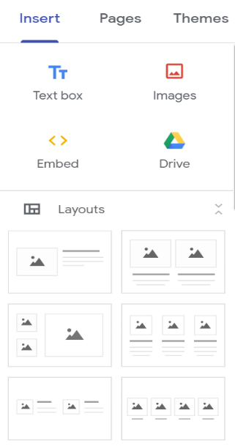  Text Box: Lets you add different sections of text.  Images: Add in pictures from your computer or from the internet.  The layouts feature lets you set out your page in different ways. There are six for you to choose from.
 |  |  | Header: You can add images used in the header, and the type of header, by clicking on these options.
Features of Good Websites |  |  | 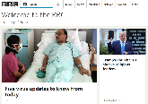  Most websites contain a home page, which introduces the website. The other pages (sub-pages) on the website go into more detail about individual topics.
Websites can be found using browsers. Browsers allow us to find our way around the worldwide web, and show us what websites look like.
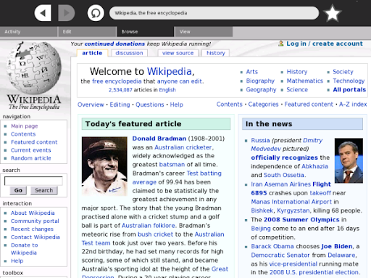  -The menus at the top of the page allow you to look at different parts of the website.  -The website name is usually visible in large font, particularly on the home page.  -Pictures are used to highlight what the text is about. Colours are used carefully.  -There is often a slogan/ logo and short description of what the website is about.  -Webpages are made up of a code called Hypertext Markup Language (HTML). You can find this by right-clicking on a page and selecting ‘Inspect.’  -The search allows you to find different things on the website.  -There are links to other areas of the website/ World Wide Web (in blue). |  |  | Making Effective Web Pages
 |  |  | 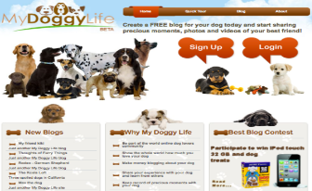  Purpose: The purpose is the reason for your web page – what is it for? You should make sure that your web page meets its purpose. |  | Navigation Pathways  Navigation Pathways are also known as breadcrumb trails.  -Hyperlinks allow different pages to be linked together.  -These links help the audience to navigate the website easily.  -The user can also keep track of where they have been on the website.
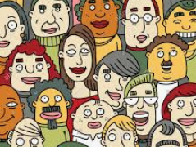
Audience: The audience are the people who your web page is aimed at. You should make decisions with your target audience in mind.
 |  |  | Copyright: You should only use images that are copyright-free. Many images are owned by people/ companies and cannot just be reused.

Key Vocabulary
web page website browser media Hypertext Markup Language (HTML) logo layout header purpose copyright home page preview navigation subpage Exerernal Link Embed

