How to use Tags:

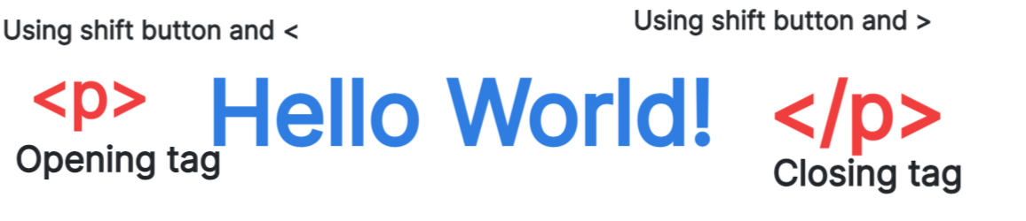

Class 2- Computing Knowledge Organiser Spring Year A- How can we speak to computers in a language that they understand?

Key Knowledge and Skills

* I can log onto my area of the web page.
* Understand that you can use HTML to talk to computers.
* Change the background colour of the web page.
* Add text to the web page.
* Use tags to organise text on a page.
* Use the whiteboard to add detail to a webpage.
* Make the title bold.
* Use tags to put text onto different lines.

Key Vocabulary

**Tab:** a second page that can be opened on the web page.

**Tag:** tells the computer what the information is.

**HTML:** Hyper Text Mark Up Language

**Text:** a collection of words or letters.

**Header:** The text that is placed at the top of the page**.**

**Footer:** The text that is written at the bottom of the page.

How to change the background colour:

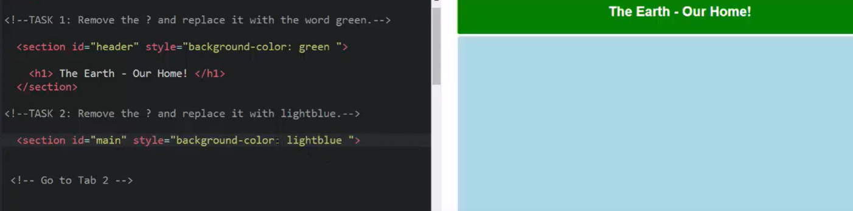

How to add text and images to the whiteboard:

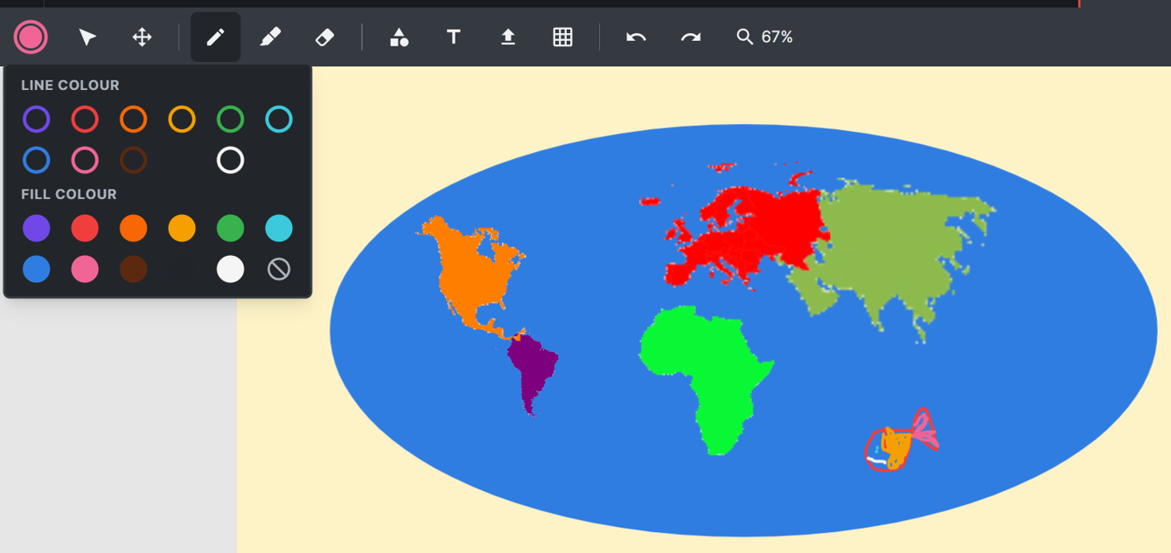

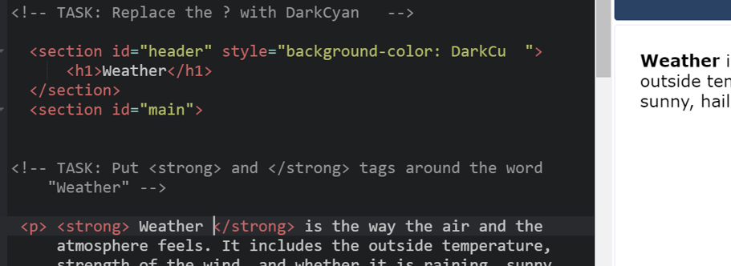

Making a title **BOLD.**

