Duction.

**Class 2- Knowledge Organiser Spring Term, Year B**

**Animals Including Humans**

Key Vocabulary

**Diet:** Everything that we eat or drink.

**Nutrition:** The food and drink we need to stay healthy.

**Data**: information such as facts and numbers.

**Carbohydrates:** Give us energy.

**Protein:** Help our bodies to grow and repair themselves**.**

**Vertebrates:** animals that have a backbone.

**Invertebrates:** animals that do not have a backbone.

**Pelvis:** hip bone

**Femur:** The thigh bone.

**Contract:** a muscle gets shorter

**Relax:** a muscle gets longer

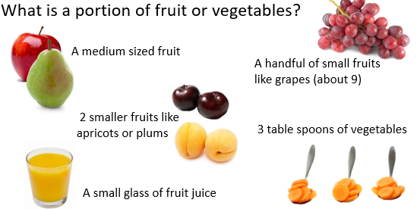

Key Knowledge

We need to eat a balanced diet to stay healthy.

A healthy diet includes 5 portions of fruit and vegetables a day.

The Eatwell Plate shows you the proportion of different kinds of foods you should eat to have a balanced diet.

Animals can be divided into vertebrates and invertebrates.

The skeleton supports the body and gives it shape.

The skeleton protects the delicate parts of the body (brain, heart and lungs).

Muscles help our body to move and give it support.

Muscles work in pairs.

