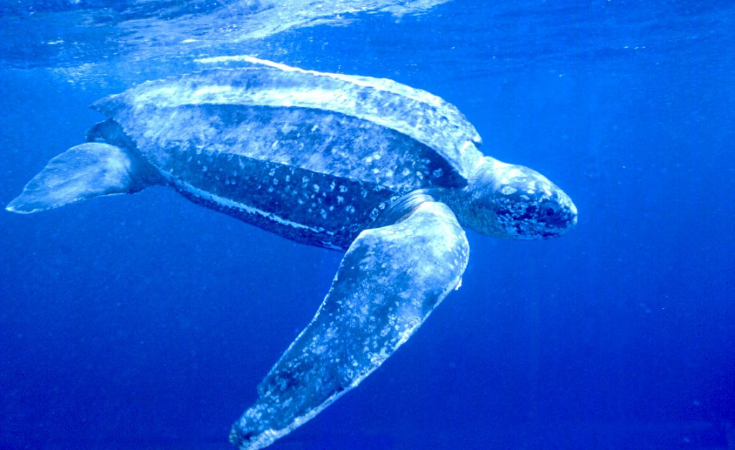

1. The leatherback sea turtle is the bigest sea turtle in the world.
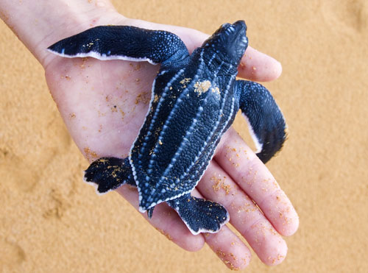
2. The leatherback sea turtle can grow to about 6 feet long.
3. The leather back sea turtle baby’s are about the size of a adults hands 4. They live to ten or twenty years or so.
The leather back sea turtle baby’s are about the size of a adults hands 4. They live to ten or twenty years or so 5. Turtles are endangered because of plastic. Turtles do not have very good eyesight so a plastic bag looks a lot like a jellyfish

Other sea turtles:

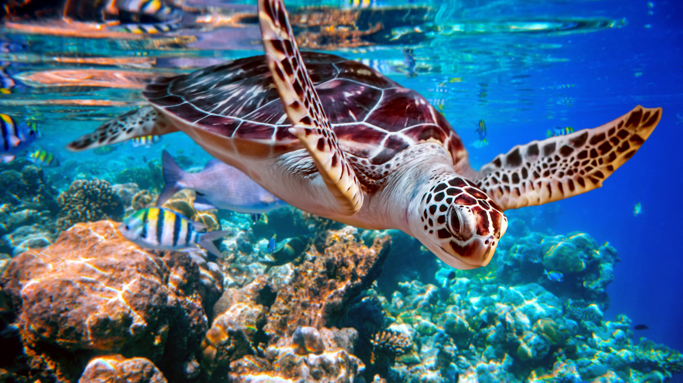

There are lots of different speeches of turtle all different.

Fun facts:

Turtles do not have very good eyesight

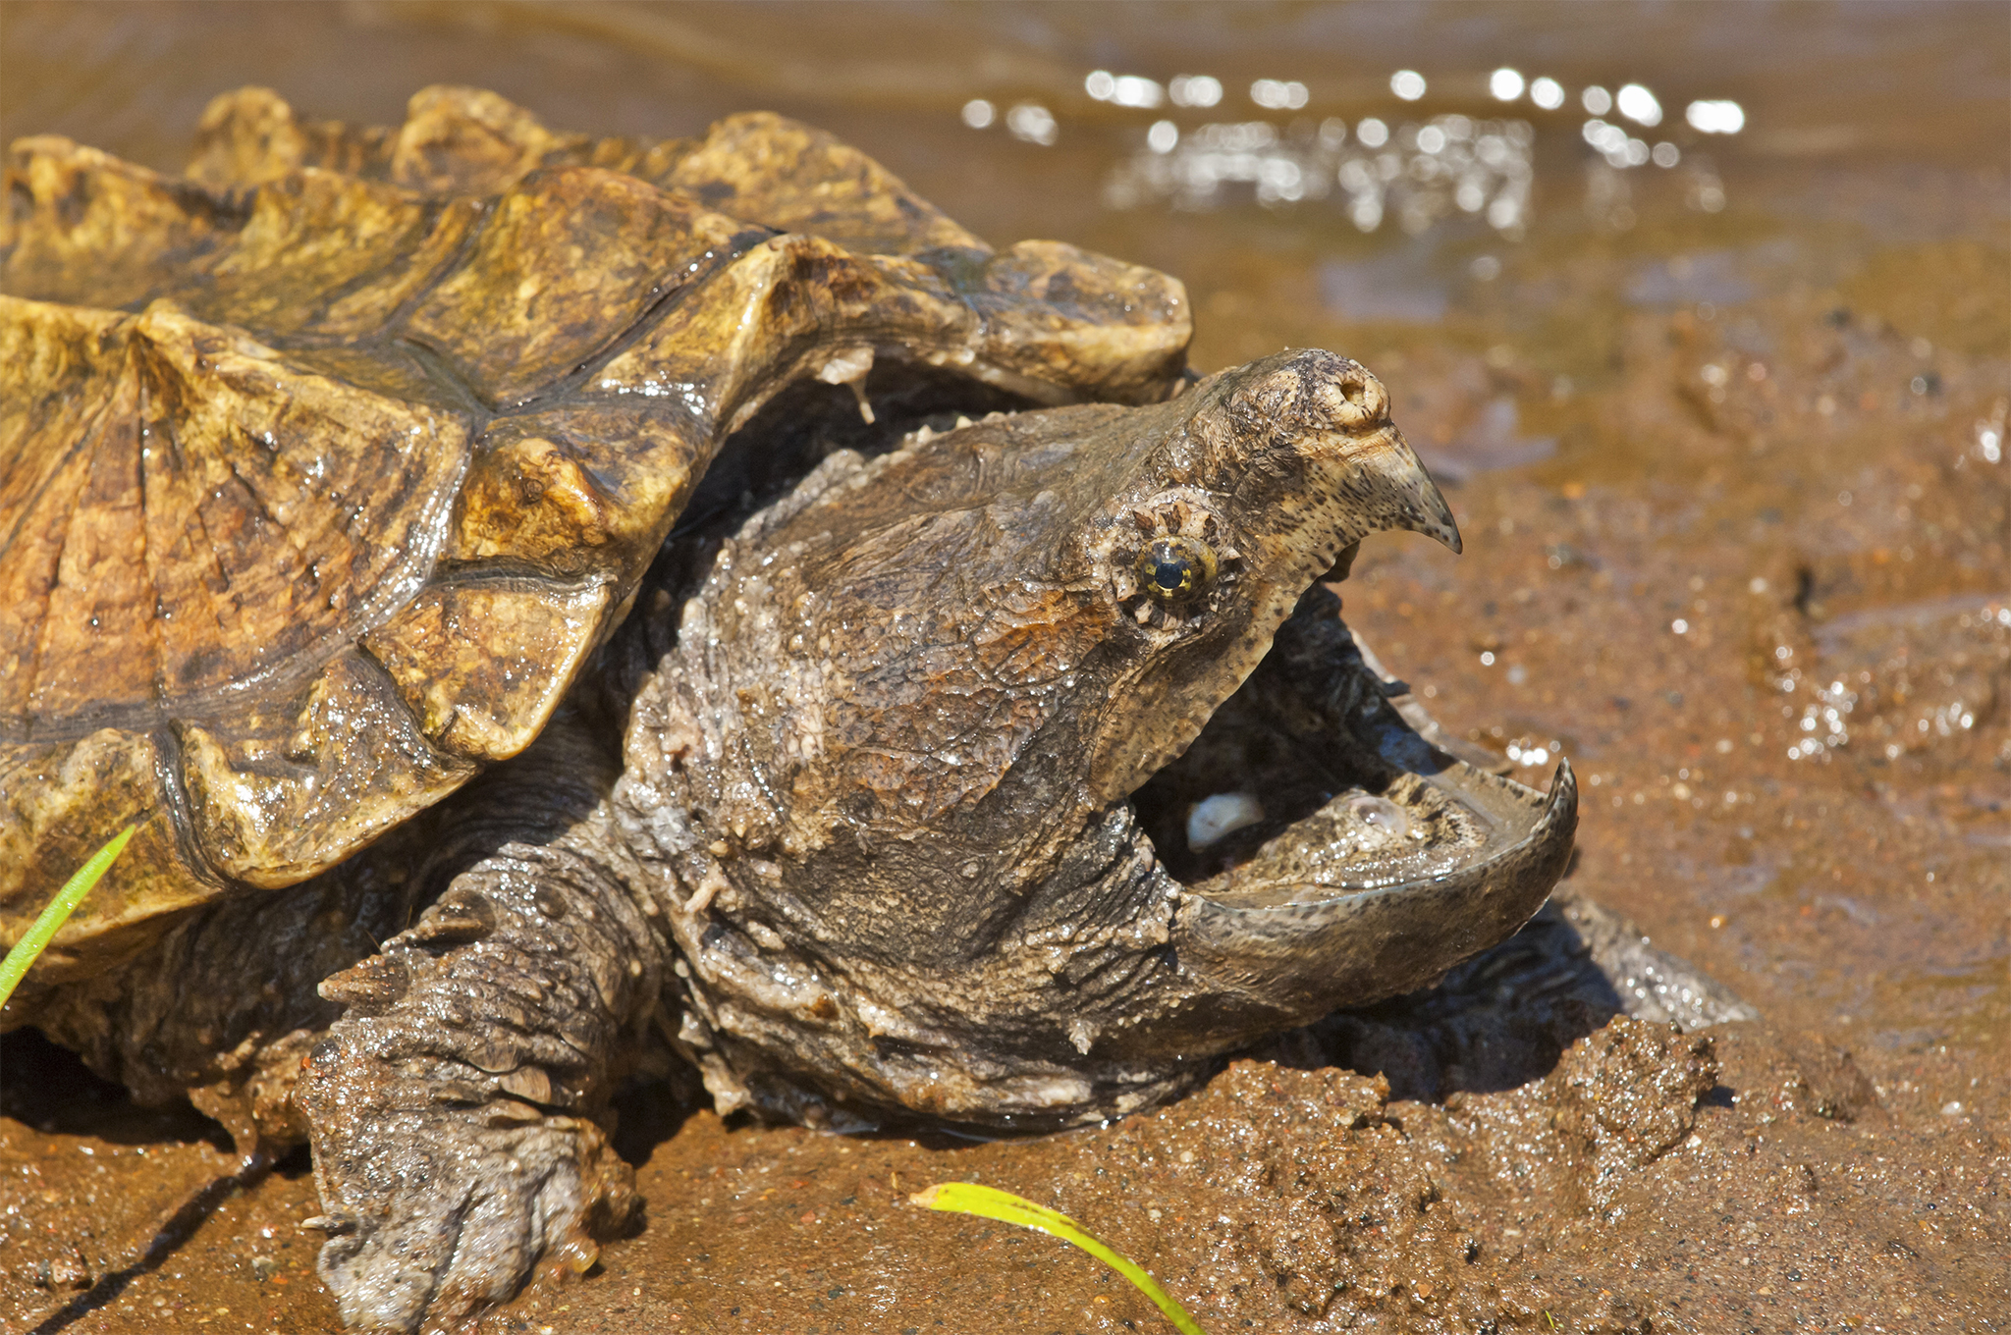
crocadile snaping turtle

