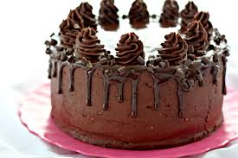
I eat half of this chocolate cake for my birthday. Can you write as many equivalent fractions as possible for one half?

A bit harder:
My brother ate sixth eighths of the cake. Can you write as many equivalent fractions as possible for sixth eighths?

