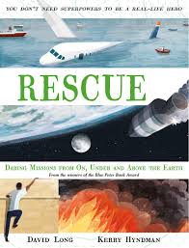
- The rescue we are reading today took place in Armenia. Where is Armenia? Locate on a world map and find out an interesting fact about it.
- Read from page 117, to page 119, ‘…a bit like he was dancing in slow motion.
- Summarise the rescue so far. You could write a short paragraph, use bullet points, use illustrations or you might be able to think of another way.

- 