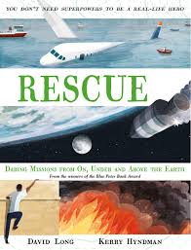
- Read pages 140 and 141.
- What an amazing rescue!
- The Apollo 13 rescue has been made into a film and I know some of you have watched it.
- Can you produce a film reel based on the rescue? You may add captions and explanations to your images if you wish.

