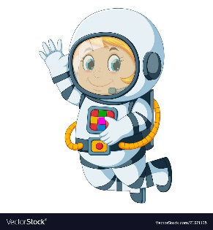
Astronaut Spellings
Week 5 3.10.21
sudden
suddenly
careful
carefully
final
finally
simple
simply
gentle
gently

