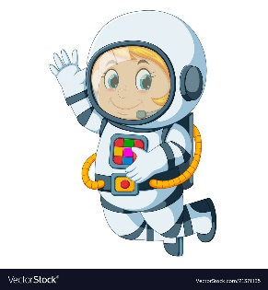
Astronaut Spellings
Week 8 8.11.21
Unit 7
school
echo
chemist
scheme
chaos
stomach
ache
anchor
character
mechanic

