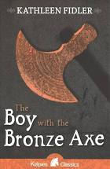
- Read the text which is the first page of the chapter called, ‘The Festival of the Sun’.
- Summarise the text. You may choose how you wish to present your work, there are a variety of ways, for example you could draw pictures and add captions.
- Now predict what you think will happen next. Again, you can choose how to present your work.
- Remember you are proving you have read and understood the text. Therefore, you will need to make sure that your work is beautifully presented and shows off your understanding perfectly.

