Duction.

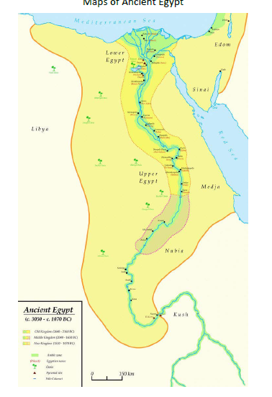

Key Vocabulary

**Civilisation:** a large group of people who live together and follow the same set of rules.

**Ancient:** very old, existed for a long time.

**Pharaoh**: the ruler in Ancient Egypt

**Vizier:** adviser to the Pharaoh

**Scribes:**

**Pyramid:**

**Tomb:**

**Subterranean:** underground

**Mummify**: A way of preserving the body after death.

**Class 2- Knowledge Organiser**

**Spring Term Year B**

**Ancient Egypt**

**Key Knowledge**

A Civilisation is a large group of people who live together and follow the same set of rules.

The ancient Egyptian Civilisation began 5,000 years ago.

It lasted around 3,000 years.

The River Nile was a very important source of water.

The Ancient Egyptians were ruled by Kings and Queens called Pharaohs.

The people in Ancient Egypt had different jobs and roles.

The Ancient Egyptians built pyramids and tombs for the Dead.

The Ancient Egyptians had more than 2000 Gods.

The Ancient Egyptians believed that a person could live again in the Afterlife.

The Ancient Egyptian Civilisation started to decline because they started to fight each other.

Cleopatra was the last Pharaoh of Ancient Egypt.

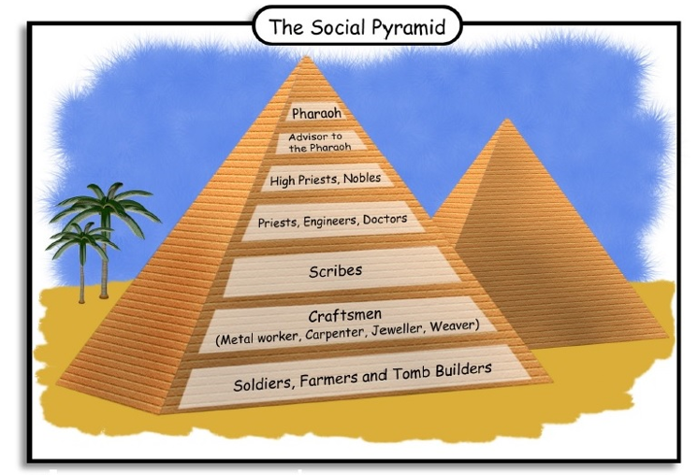

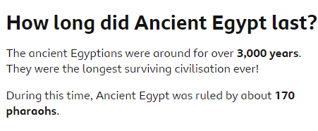

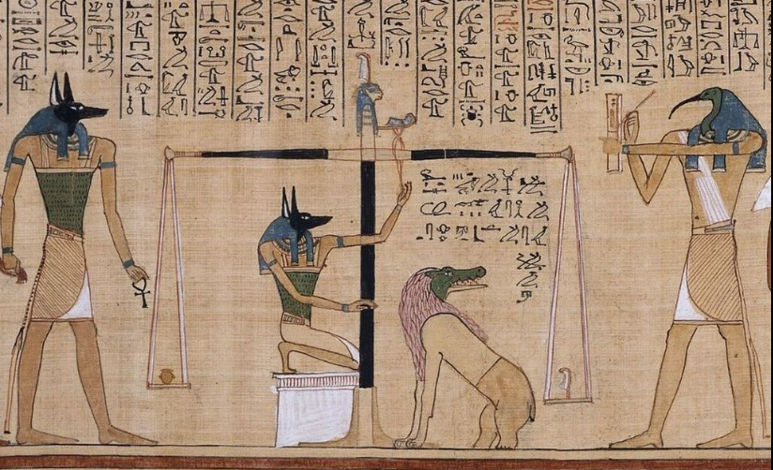

The Book of The Dead was placed in a tomb to protect and help the person in the Afterlife. It included spells and magic formulas.

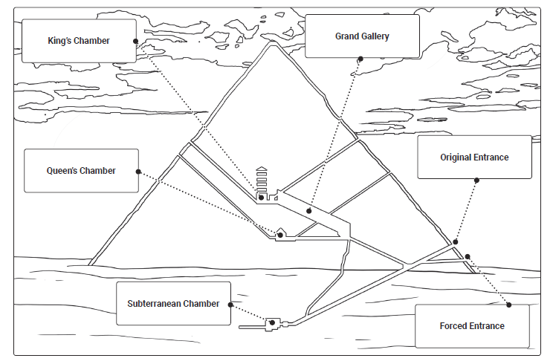

|  |  |  |  |  |  |  |  |  |
| --- | --- | --- | --- | --- | --- | --- | --- | --- |
| Timeline in Britain | 4000 BCE |  |  |  |  |  |  |  |
| 7500 BCE | 2950 BCE | 264BCE | 2555BCE | 1539 BCE | 1332BCE | | 332BCE | 51BCE |
|  |  |  |  |  |  | |  |  |