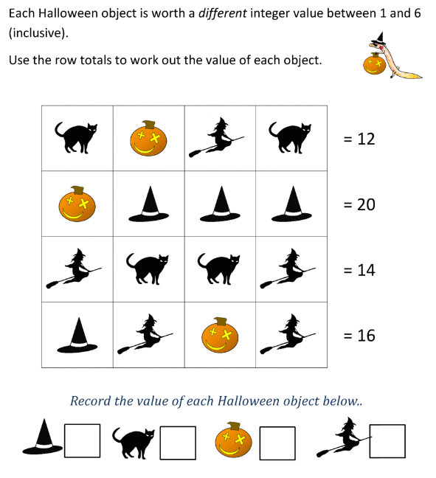

**How did you work it out?  
Explain your reasoning.**

_________________________________________________________________________________________________________________________________________________________________________________________________________________________________________________________________________________________________________________________________________________________________________________________