Duction.

Key Vocabulary

CE: Common Era (the years after 0000)

AD: Anno Dominii (the years after 0000)

BCE: Before the Common Era (the years before 0000)

BC: Before Christ (the years before 0000)

Invader: someone who enters by force in order to conquer.

Settler: a person who moves to a new place intending to stay there.

Anglo-Saxon: a mix of tribes from Germany, Denmark and The Netherlands.

Settlement: a place where people live.

Kingdom: a country or land ruled by a King or Queen.

Boss: A piece of metal in the centre of a shield.

Scabbard: a piece of leather used to hold a blade/ sword.

Dyke: a structure built by King Offa to defend his Kingdom.

Reign: The length of time a King or Queen rules a land.

There were 7 Anglo-Saxon Kingdoms: Northumbria, Mercia, Wessex, Sussex, Kent, Essex and East Anglia

Class 2- Knowledge Organiser Autumn Term 1, Year B

**Why did the Anglo-Saxons come to Britain?**

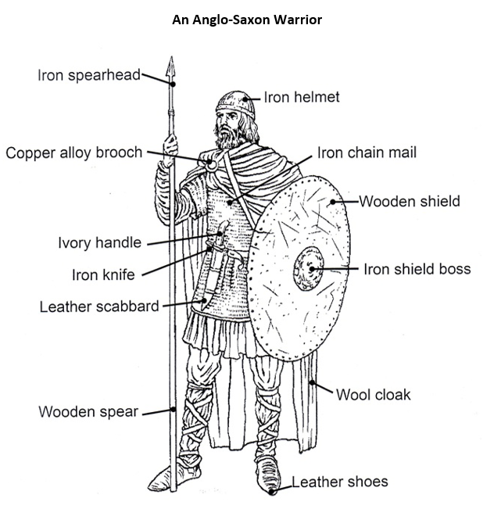

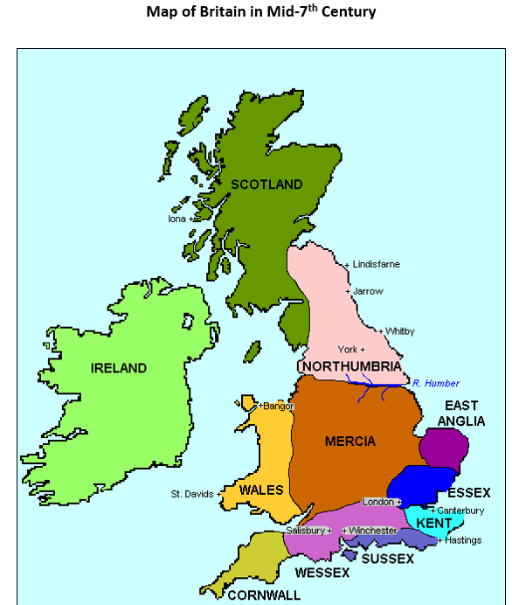

Key Knowledge

I can explain the meaning of ‘Invaders and Settlers’ and talk about the difference between them.

I can explain why the Anglo-Saxons came to settle in Britain.

I can place significant dates concerning the Anglo-Saxons on a timeline of British history.

I can explain what natural resources would make a good site for a settlement.

I can explain the position of warriors in Anglo-Saxon society.

I can describe the appearance of an Anglo-Saxon warrior.

I can describe how the Anglo-Saxon tribes settled into first 5, then 7 main kingdoms.

I can name some of the Anglo- Saxon Kings.

I find out about one particular Anglo-Saxon King and share my knowledge with others.

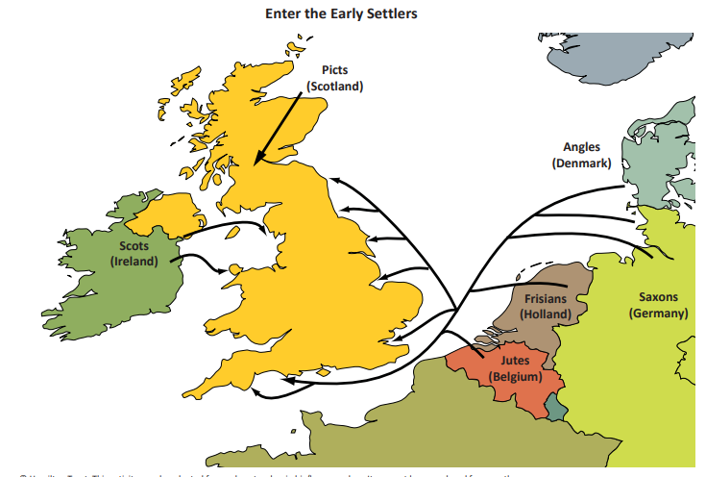

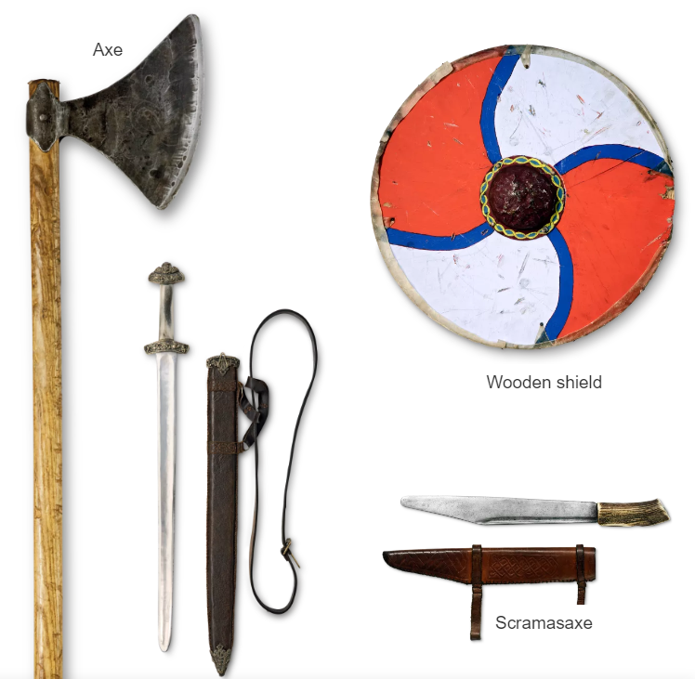

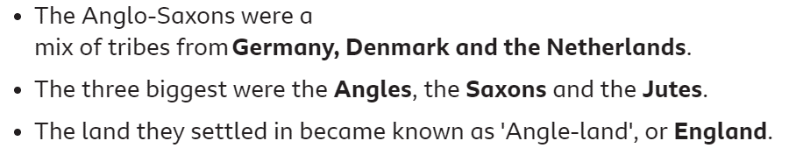

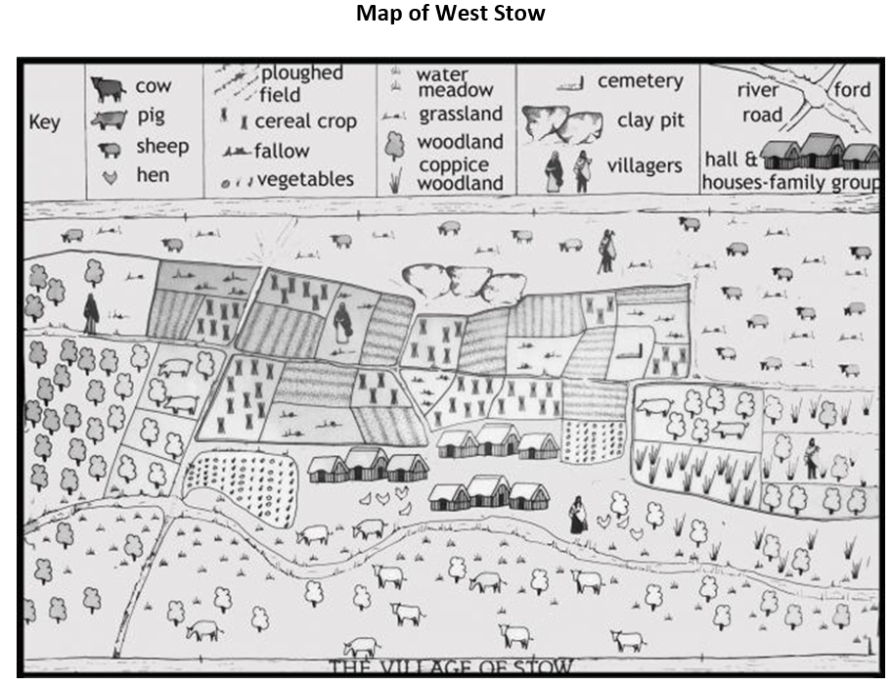

This map shows an early Anglo-Saxon Settlement. The people were farmers. They lived peacefully in the village. They made their own iron, pottery and cloth. They kept sheep, pigs, cattle, ponies, geese and hens. They hunted with dogs and fished in the river.

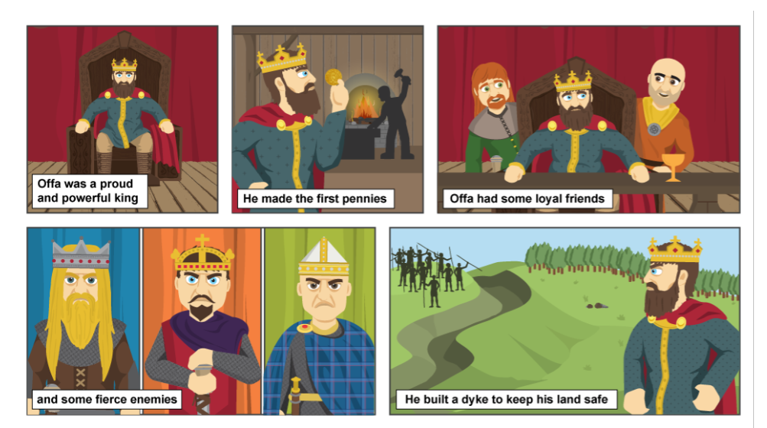

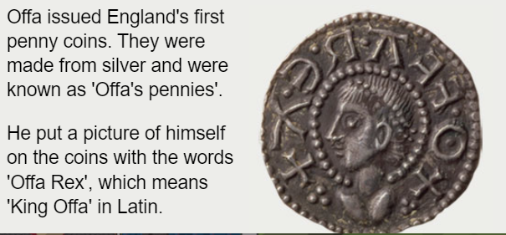

Offa built a dyke to keep his land safe.

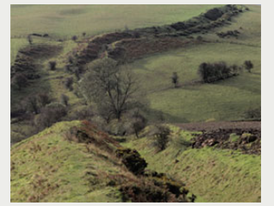

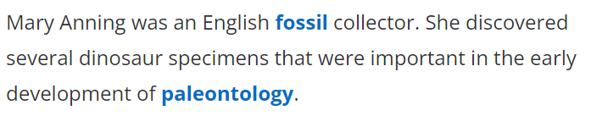

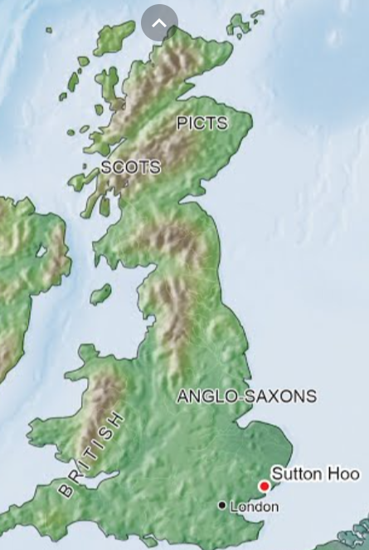

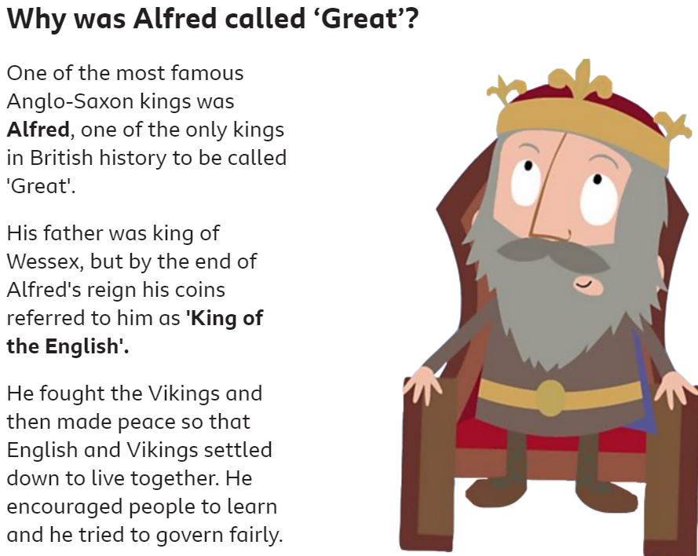

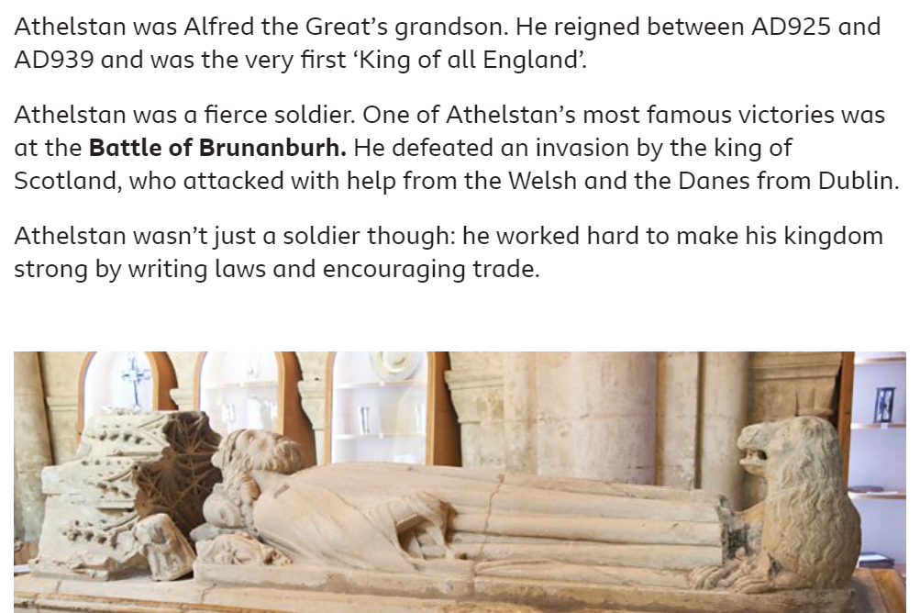

Pieces of this helmet, were discovered at Sutton Hoo, along with a huge ship! Archaeologists discovered a burial chamber filled with treasures. The coins found in the grave dated from 610-635 No one knows who was buried at the site, although many people believe it was an Anglo-Saxon King. It could be King Readwald who ruled between 616-625 CE or Eorpwald who died in 627-628 CE. It could also be one of the later Kings!

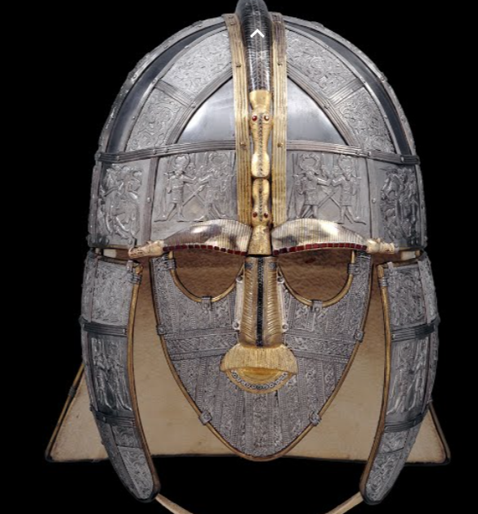

King Athelstan

‘King of all England’

925-939 CE

Norman Conquest

1066

King Alfred ruled

871-899 CE

Offa King of Murcia

757-796 CE

Readwald King of East Anglia

616-625 CE

Larger groups of Anglo Saxons arrive

Around 450 CE

First Anglo Saxon Invaders

400 CE

Romans leave Britain

410 CE