Read Write Inc. at North Stainley

At North Stainley we aim for all our children to become fluent, confident readers who are passionate about reading.
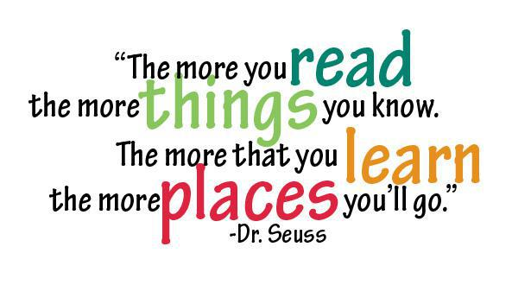

What is Read Write Inc?
Read Write Inc (RWI) is a phonics complete literacy programme which helps all children learn to read fluently and at speed so they can focus on developing their skills in comprehension, vocabulary and spelling. The programme is designed for children aged 4-7.
RWI was developed by Ruth Miskin and more information on this can be found at https://ruthmiskin.com/en/find-out-more/parents/.

Reception
In Reception all children will learn how to ‘read’ the sounds in words and how those sounds can be written down.

Reading
The children:
- learn 44 sounds and the corresponding letters/letter groups using simple picture prompts – see below
- learn to read words using Fred talk and sound blending
- read from a range of storybooks and non-fictions books matched to their phonic knowledge
- work well with partners
- develop comprehension skills in stories by answering 'Find It' and 'Prove It' discussion questions

Writing
The children:
- learn to write and form the letters/letter groups which represent the 44 sounds with the help of fun phrases
- learn to write words by using Fred Talk
- learn to build sentences by practising sentences out loud before they write

Talking
The children
- They work in pairs so that they:
- answer every question
- practise every activity with their partner
- take turns in talking and reading to each other
- develop ambitious vocabulary

Five key principles underpin the teaching in all Read Write Inc. sessions:

Purpose – know the purpose of every activity and share it with the children, so they know the one thing they should be thinking about
Participation – ensure every child participates throughout the lesson. Partnership work is fundamental to learning
Praise – ensure children are praised for effort and learning, not ability
Pace – teach at an effective pace and devote every moment to teaching and learning
Passion – be passionate about teaching so children can be engaged emotionally.

Children will be taught how to read as follows:
Before you start to teach your child, practise saying the sounds below. These are the sounds we use to speak in English.

Fred Talk
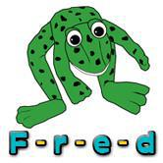
We use pure sounds (‘m’ not’ muh’,’s’ not ‘suh’, etc.) so that your child will be able to blend the sounds into words more easily.
At school we use a puppet called Fred who is an expert on sounding out words! we call it, ‘Fred Talk’. E.g. m-o-p, c-a-t, m-a-n, sh-o-p, b-l-a-ck.

The following video is an example of blending sounds with Fred. https://www.youtube.com/watch?v=dEzfpod5w_Q

The children are taught the sounds in 3 sets.

Step 1:
Set 1 Sounds are taught in the following order together with rhymes to help children form the letters correctly and instantly recognise sounds ready for blending.

Set 1
Sound | Rhyme
m | Down Maisie then over the two mountains. Maisie, mountain, mountain.
a | Round the apple, down the leaf.
s | Slide around the snake
d | Round the dinosaur's back, up his neck and down to his feet.
t | Down the tower, across the tower,
i | Down the insects body, dot for the head.
n | Down Nobby and over the net.
p | Down the plait, up and over the pirates face.
g | Round the girls face, down her hair and give her a curl
o | All around the orange
c | Curl around the caterpillar
k | Down the kangaroos body, tail and leg
u | Down and under the umbrella, up to the top and down to the puddle
b | Down the laces, over the toe and touch the heel
f | Down the stem and draw the leaves
e | Slice into the egg, go over the top, then under the egg
l | Down the long leg
h | Down the horse's head to the hooves and over his back
sh | Slither down the snake, then down the horse's head to the hooves and over his back
r | Down the robot's back, then up and curl
j | Down his body, curl and dot
v | Down a wing, up a wing
y | Down a horn, up a horn and under the yak's head.
w | Down, up, down, up the worm.
th | Down the tower, across the tower, then down the horse’s head to the hooves and over his back
z | Zig-zag-zig, down the zip.
ch | Curl around the caterpillar, , then down the horse's head to the hooves and over his back
qu | Round the queen’s head, up to her crown, down her hair and curl
x | Cross down the arm and leg and cross the other way
ng | A thing on a string
nk | I think I stink

Please do not use letter names at this early stage.
This video helps to hear how to pronounce sounds correctly.
https://www.youtube.com/watch?v=s6OiU2h3sUI

Children will also use pictures and actions for each sound to help recognise the sound and then form the shape of the sound, as well as making it interactive and more memorable.
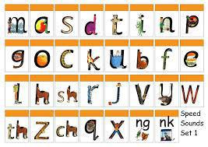

Step 2:
The children are then taught Set 2 Sounds - the long vowels. When they are very confident with all of set 1 and 2 they are taught Set 3 Sounds.

Long vowel sound | Set 2 Speed Sound cards  Teach these first | Set 3 Speed Sound cards
ay | ay: may I play | a-e: make a cake | ai: snail in the rain
ee | ee: what can you see | ea: cup of tea | e: he me we she be
igh | igh: fly high | i-e: nice smile
ow | ow: blow the snow | o-e: phone home | ao: goat in a boat
oo | oo: poo at the zoo | u-e: huge brute | ew: chew the stew
oo | oo: look at a book
ar | ar: start the car
or | or: shut the door | aw: yawn at dawn
air | air: that’s not fair | are: share and care
ir | ir: whirl and twirl | ur: nurse for a purse | er: a better letter
ou | ou: shout it out | ow: brown cow
oy | oy: toy for a boy | oi: spoil the boy
ire |  | ire: fire fire!
ear |  | ear: hear with your ear
ure |  | ure: sure it’s pure?

Nonsense words (Alien words)
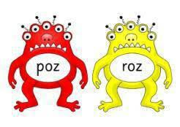
As well as learning to read and blend real words children will have plenty of opportunities to apply their sound recognition skills on reading ‘Nonsense words’. These words will also feature heavily in the Year One Phonics Screening check in the summer term. https://www.theschoolrun.com/year-1-phonics-screening-check will provide further information on the Screening check.

Step 3:
Children will be introduced to ‘Ditty books’ when they successfully begin to read single words. The short vowels should be kept short and sharp:
Children use sound-blending (Fred Talk) to read short ditties. They will bring these home once they have read and discussed the book in class. Children will then be challenged to use their developing phonic knowledge to write short sentences.
Within all the books children will have red and green words to learn to help them to become speedy readers. Red words are words that are not easily decodable and challenge words to extend children’s vocabulary. Green words are linked to the sounds they have been learning and are easily decodable.

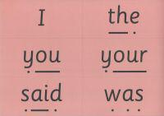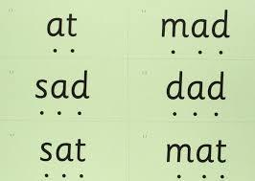

Dots and dashes represent the sound each letter makes.
Once your child has been introduced and taught these words in school we will send them home for you to continue practising with your child.
During the RWI session children will read the book three times and at each new reading they will have plenty of opportunities to practise using their developing comprehension skills. You may have heard your child talking about ‘hold, edit or build a sentence’.
Hold a sentence is an activity that encourages children to remember a whole sentence while focusing on spelling and punctuation.
Build a sentence is to give children the opportunity to create their own sentence to that shows the meaning of a word and edit a sentence allows the children to critique a sentence using their knowledge of spelling punctuation and grammar. Children complete a longer piece of independent writing, which gives them the opportunity to show off their creativity and to practice their spelling, grammar and punctuation.

Spelling Quiz

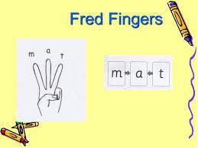

‘Spelling quiz’ is another way to check in on your child’s understanding. Children will use first use ‘Fred fingers’ to first sound out a word before they write it down. Children learn how to spell rather than just ‘get tested’. Furthermore, this way of teaching spellings allows children to use Fred fingers whenever they get stuck with spelling a word, as well as preparing for Year One. Children pinch each sound on fingers before writing the word.

To help at home:
Your child will start to bring books home when they are confident readers. Please help them to read and give lots of praise!
If you have any other questions about RWI, please speak with Miss. Gregory

Phonics Screening Check Year One
What is the Year 1 phonics screening check?
The Year 1 phonics screening check is a short, light-touch assessment to confirm whether individual pupils have learnt phonic decoding to an appropriate standard.
It will identify the children who need extra help so they are given support by their school to improve their reading skills. They will then be able to retake the check so that schools can track pupils until they are able to decode.
Further information can be found on this website: https://www.theschoolrun.com/year-1-phonics-screening-check.

Useful websites for Parents
Please find a list of websites that you may find useful in helping you and your child learn about phonics. Games and fun activity websites are also included.
http://jollylearning.co.uk/ - Games and information for parents
http://www.phonicsplay.co.uk/ - many games to play
http://www.bbc.co.uk/bitesize/ks1/literacy/phonics/play/ - fun games for the children to play
http://www.ictgames.com/literacy.html - fun games for the children to play
http://www.kenttrustweb.org.uk/kentict/kentict_home.cfm - fun games for the children to play and information for parents
http://www.ngfl-cymru.org.uk/ - fun games for the children to play
http://www.starfall.com/ - fun games for the children to play
http://www.firstschoolyears.com/ - fun games for the children to play
Sparklebox - lots of resources to print off and help you support your child at home
BBC Bitesize - many games to play covering all areas of the curriculum

