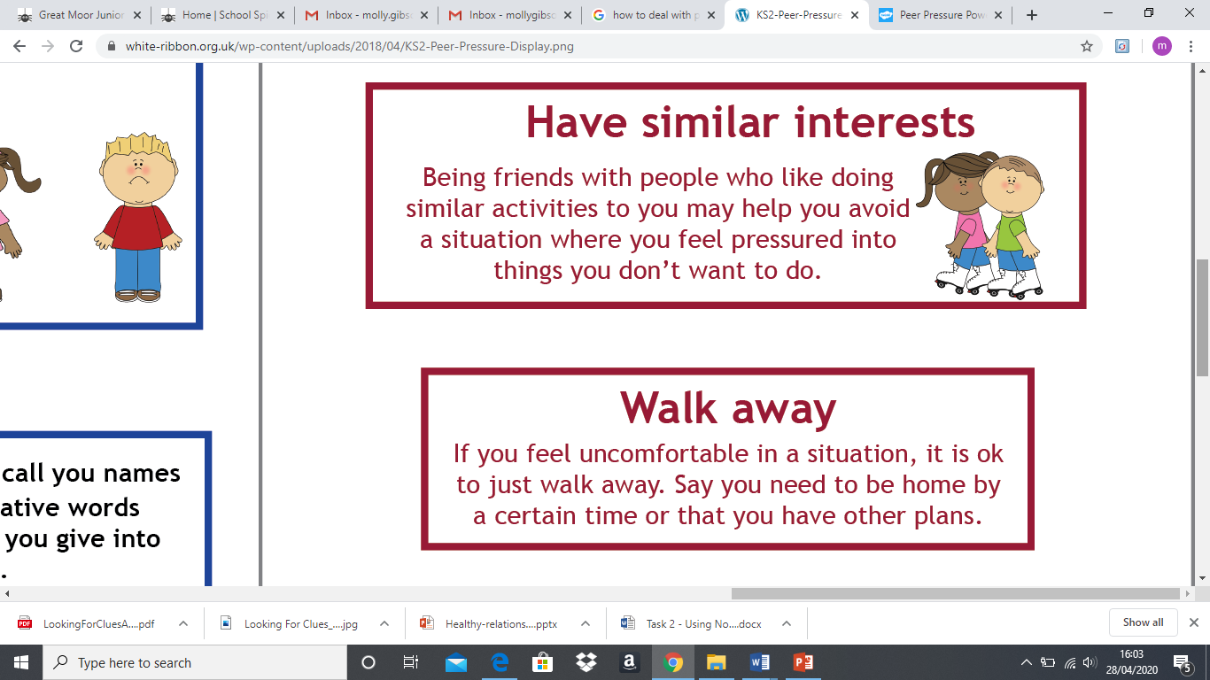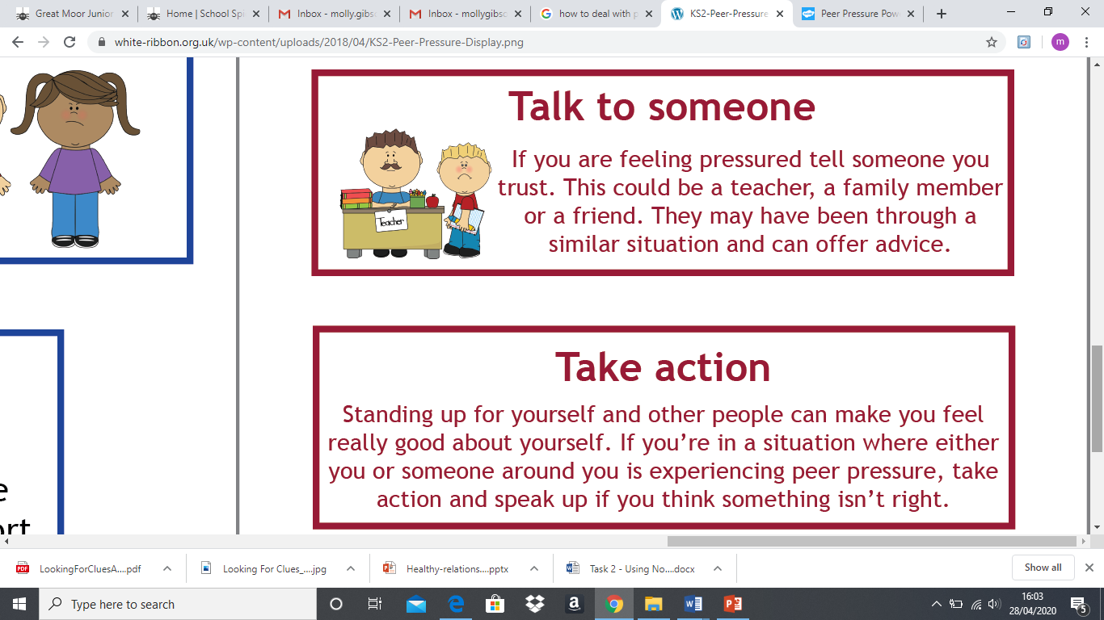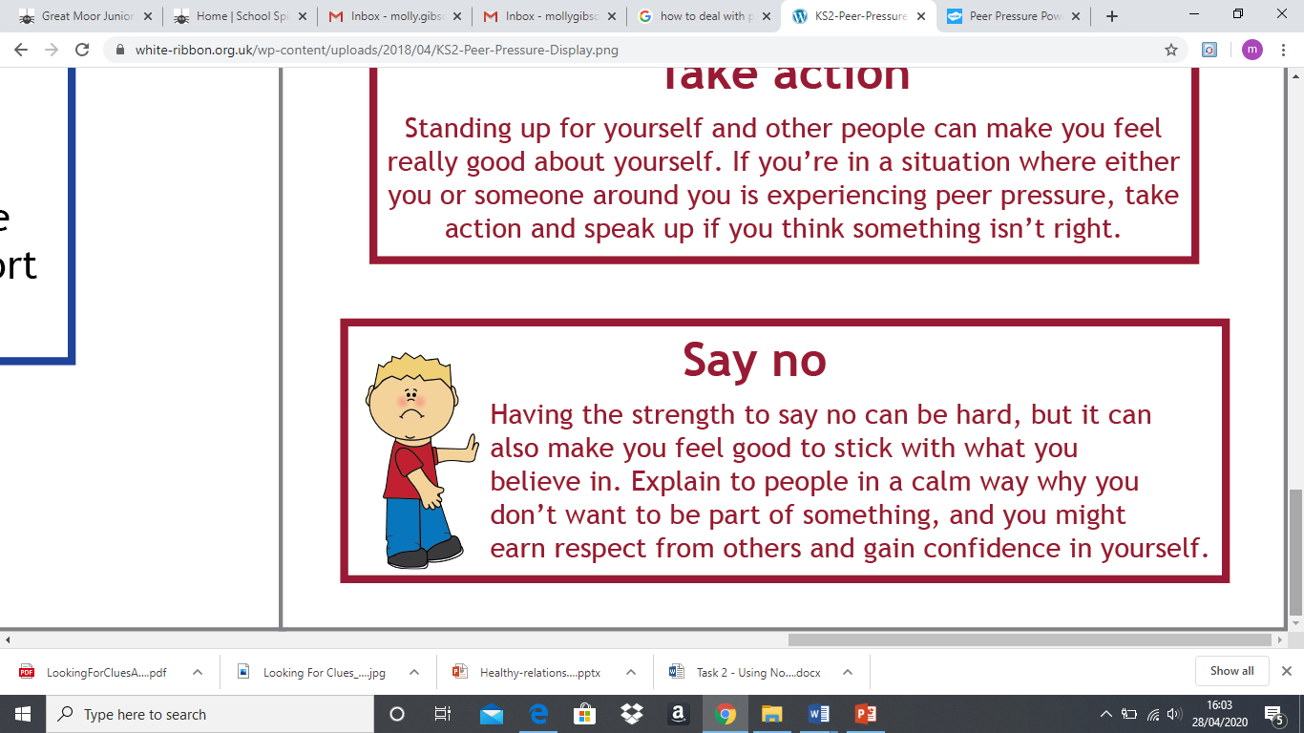

**How to deal with peer pressure**

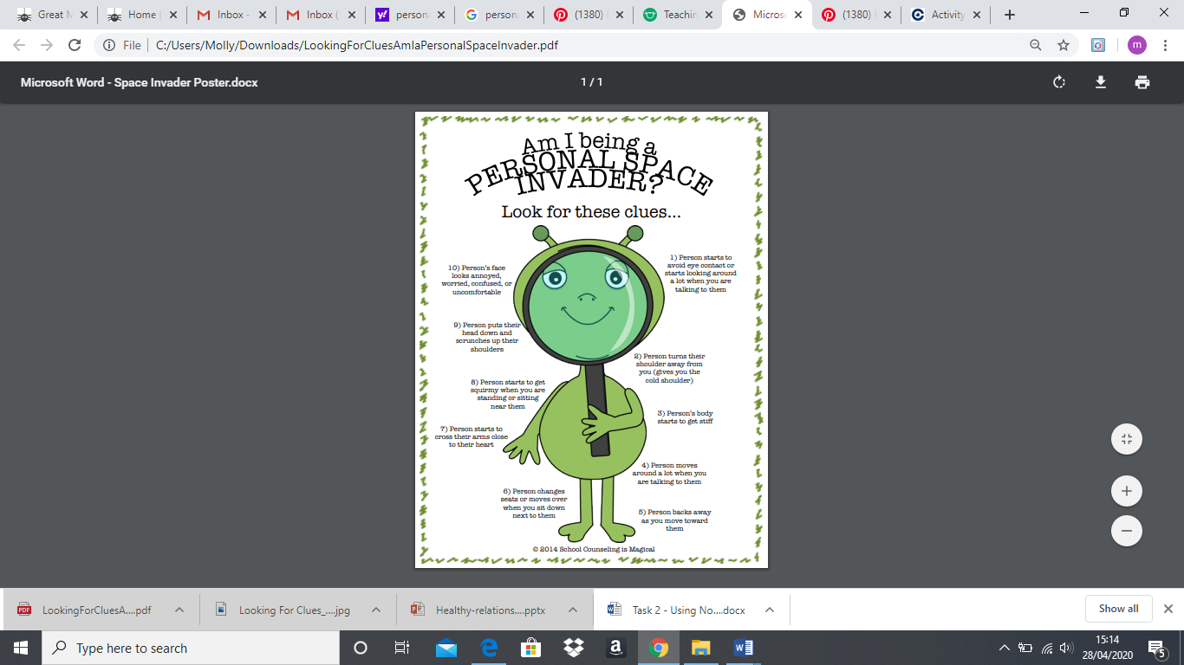

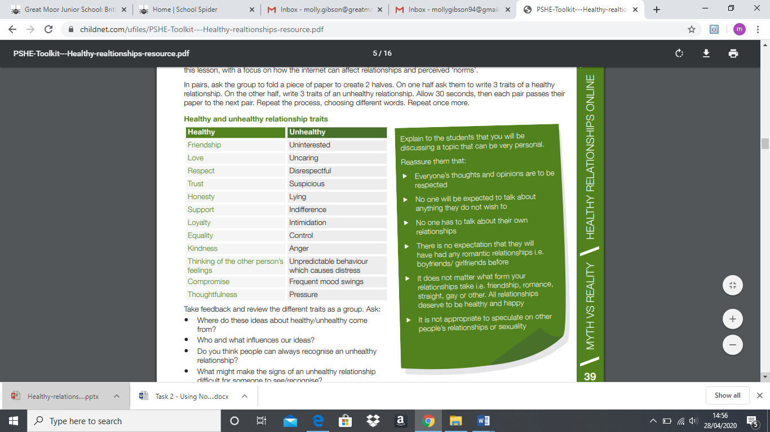

|  |
| --- |
| Define: civil partnership |
| A demonstration of commitments made between two people who love and care for each other. |

|  |
| --- |
| Define: peer pressure |
| When your peers try to convince you to act or behave in a certain way. |