Our Science Super-Heroes!

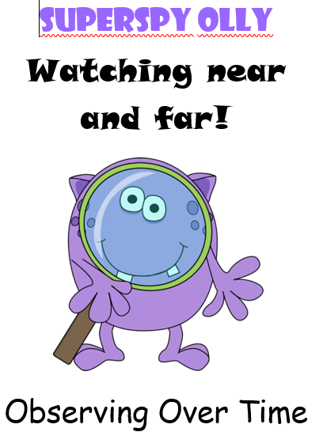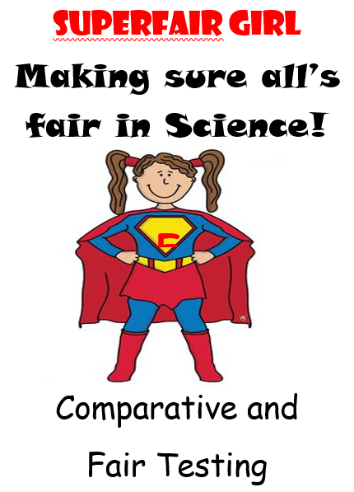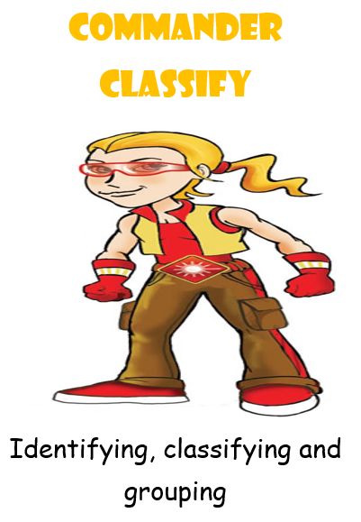

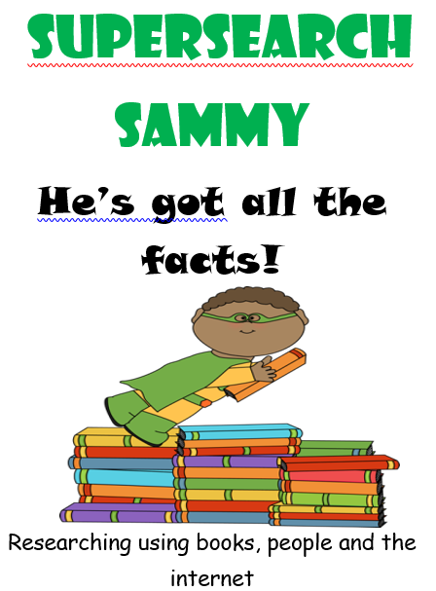

**Class 2- Science Knowledge Organiser Autumn Term 1, Year B**

**Our Big Question: How Can Water Exist In Three Different Forms?**

Key Knowledge

I can group materials into solids and liquids and explain their properties that make a material a solid or a liquid.

I can explain how the particles are arranged in solids, liquids and gases.

I can describe some of the properties of gases.

I can find evidence to show that air is made up of matter and explain what I have found out.

I can ask and investigate questions about evaporation and condensation.

Solid

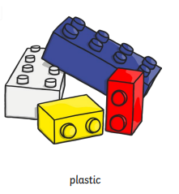 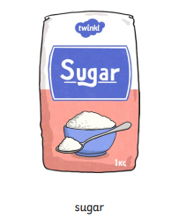 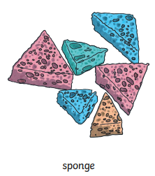

Liquid

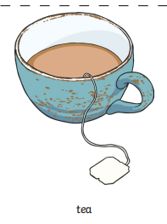 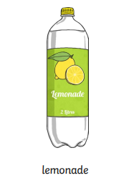 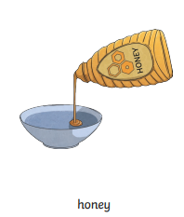

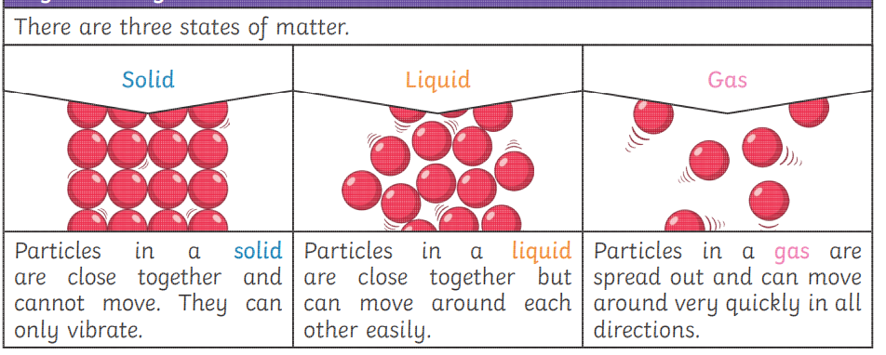

Key Vocabulary

Solid: A materials that keeps its shape. They can be hard, soft or squashy.

Liquid: A material that you can pour. It takes the shape of its container.

Gas: It has no fixed shape or size. They can spread out to fill the room.

Particles: one of the very small parts of matter (atom, molecule).

Thermometer: an instrument used to measure temperature.

Evaporate: When a liquid turns into a gas.

# **Gas**

