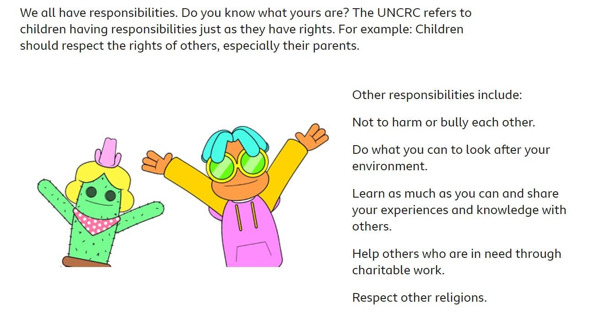

Vocabulary

**Right**: something you have the power to have or to do.

**Responsibility:** having a duty towards something or someone.

**UNCRC**: United Nations Convention on the Rights of the Child.

**Environment**: everything around us. All our surroundings including air, water, soil, plants and animals.

**Local area**: Existing in or belonging where you live.

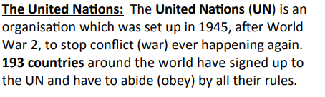

The United Nations sets out these rights. Governments and adults need to work together to make sure that all the children in the world have these rights.

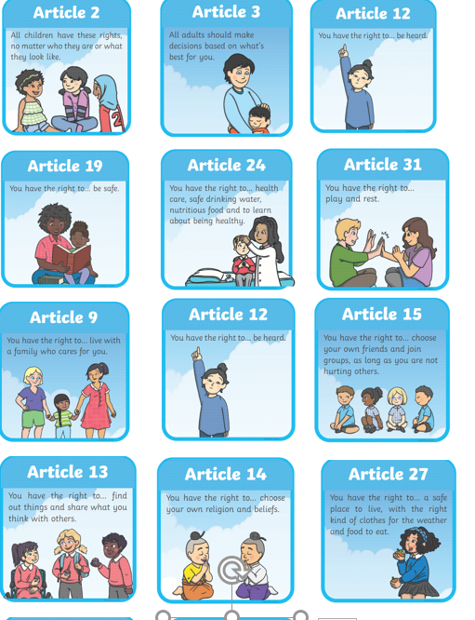

PSHE: What are we responsible for?

Who is responsible for us at school?

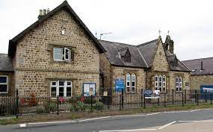

How can we look after our local area?

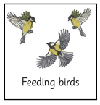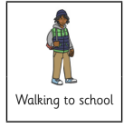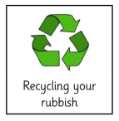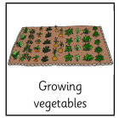 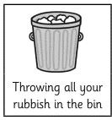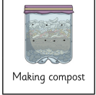

Key Questions

What is the difference between a right and a responsibility?

Does everyone have the same rights?

What can we do to help people who are not having their rights met?

Does everyone have the same responsibilities? If not why not?