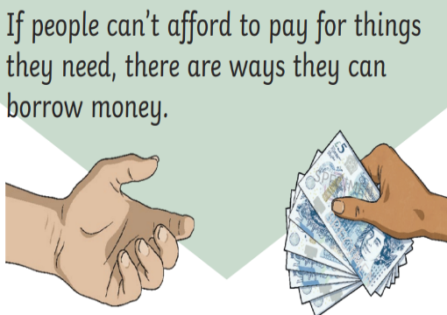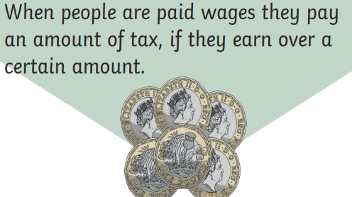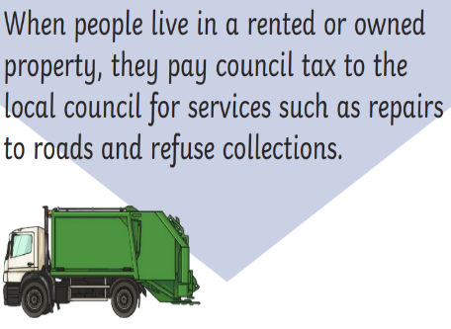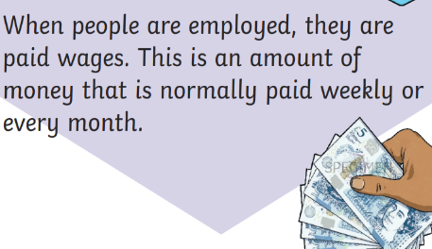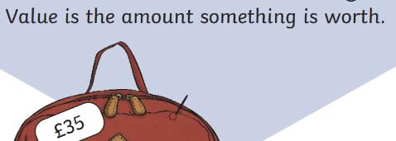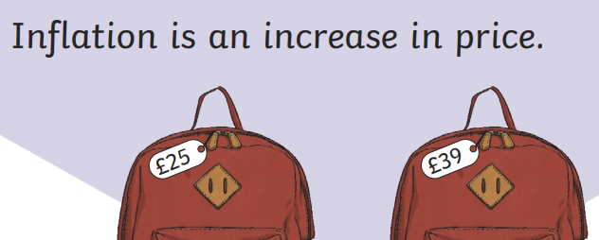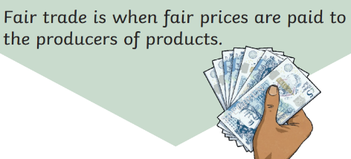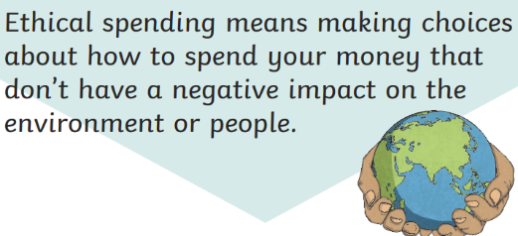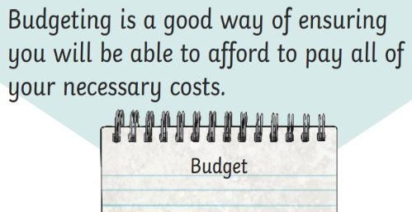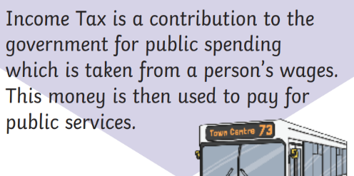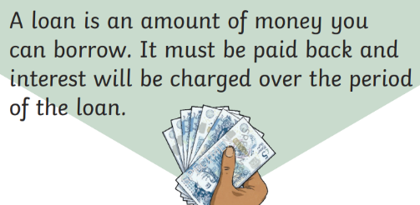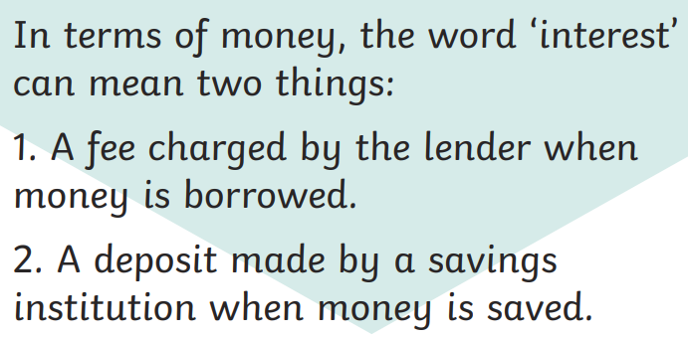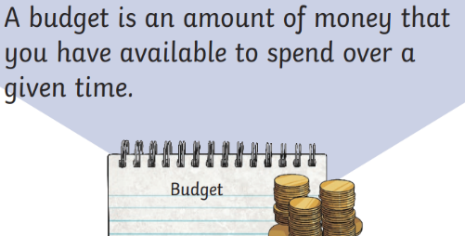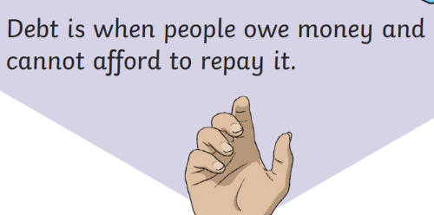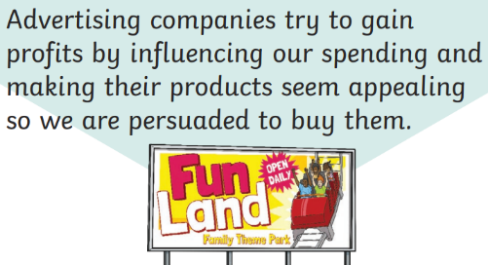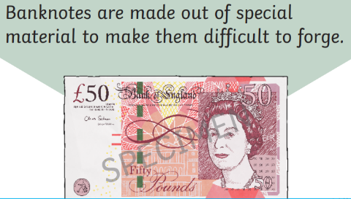

**Key Knowledge**

**How can we manage money?**

I can explain some financial risks and discuss how to avoid them.

I understand how retailers try to influence our spending.

I can discuss the spending decisions people have to make.

I can explain why budgeting can be helpful and how a budget can be made.

I can discuss the impact money can have on people’s emotional wellbeing.

I can explain the impact spending has on our environment.

**Key Vocabulary**

money

investment

gain

interest

risk

value

manufacturer

retailer

advertise

consumer

price

repayment

prioritise

wages

income

spending

loan

tax

society

cost

**PSHE Knowledge Organiser – Living in the Wider World – Money Matters**