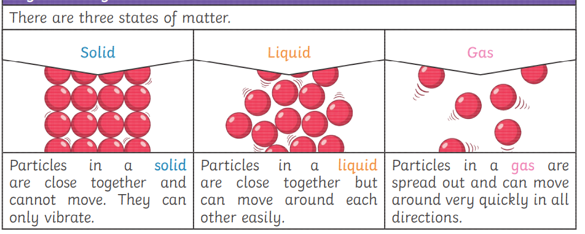

Key Knowledge

I can explain what I know and what they want to know about states of matter.

I can group materials into solids and liquids and explain their properties that make a material a solid or a liquid.

I can explain how the particles are arranged in solids, liquids and gases.

I can describe some of the properties of gases.

I can find evidence to show that air is made up of matter and explain what I have found out.

I can use a thermometer to read the temperature.

I can ask and investigate questions about evaporation and condensation.

I can use scientific language to explain evaporation and condensation to others.

I can ask questions, and set up a simple fair test to investigate factors that speed up evaporation.

I can explain the part that evaporation and condensation plays in the water cycle

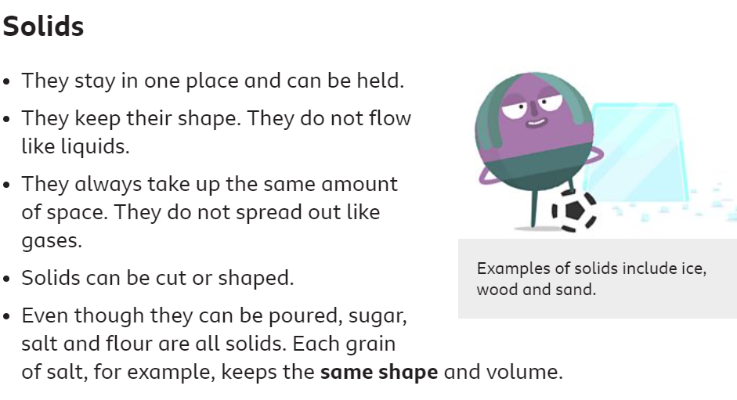

**Class 2- Science Knowledge Organiser Autumn Term 1, Year B**

**Our Big Question: How Can Water Exist In Three Different Forms?**

Key Vocabulary

States of Matter: Any material can exist in one of three forms: solid, liquid or gas. Some materials can change from one state to another and back again.

Solid: Materials that keep their shape unless a force is applied to them. They can be hard, soft or squashy.

Liquid: a material that can flow and does not have a definite shape. It takes the shape of its container.

Gas: has no fixed shape or size. They can spread out to fill the container or room.

Particles: one of the very small parts of matter (atom, molecule).

Water Vapour: Water that takes on the form of a gas.

Melting: a change of a solid into a liquid when heat is applied.

Freezing: a change in state from a liquid to a solid, usually due to a drop in temperature.

Thermometer: an instrument used to measure temperature.

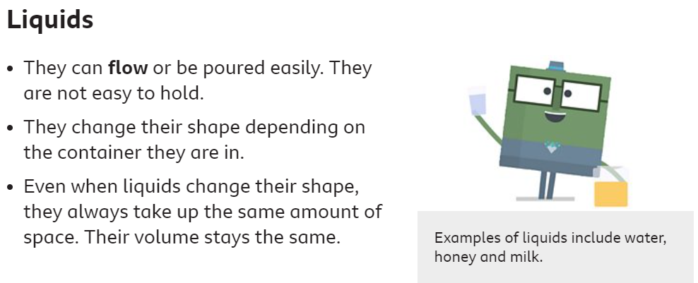

# 

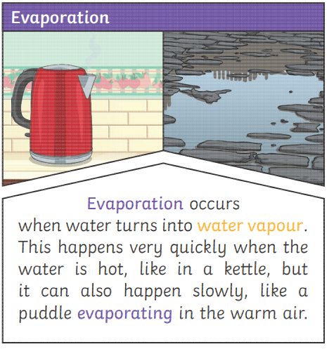

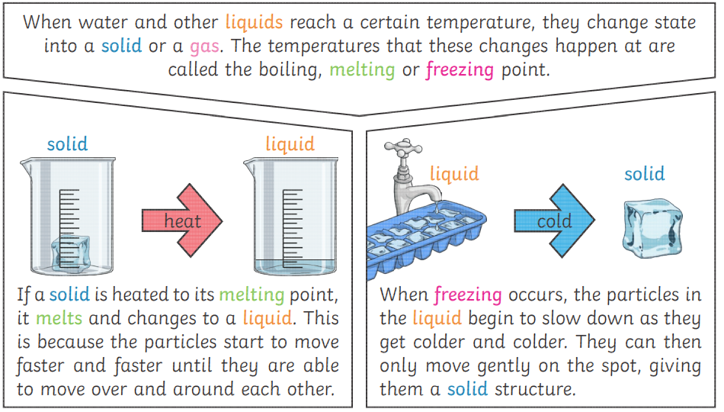

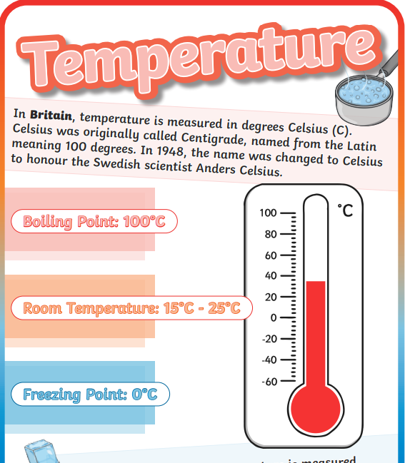

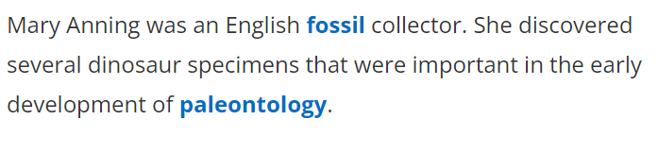

Our Science Super-Heroes!

