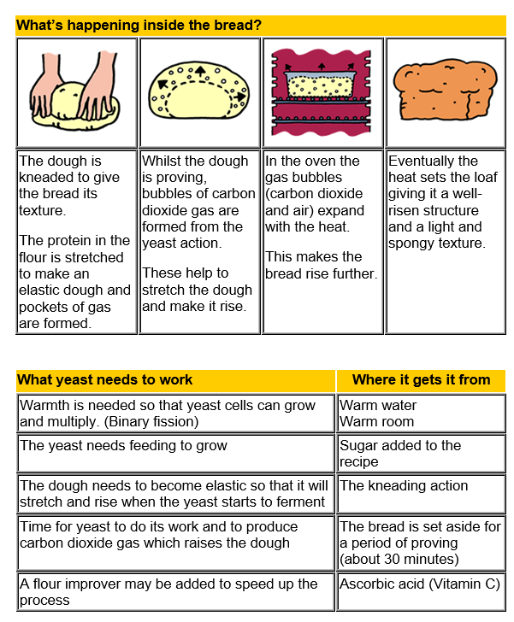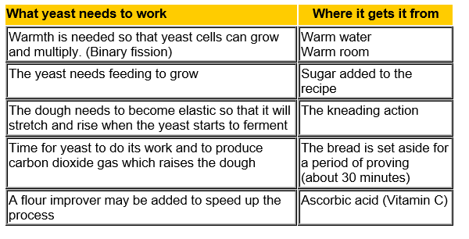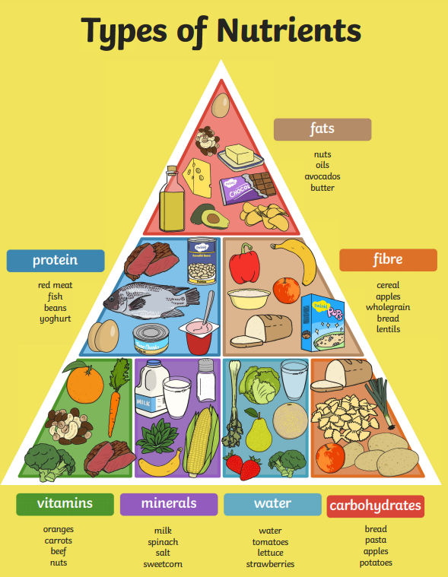**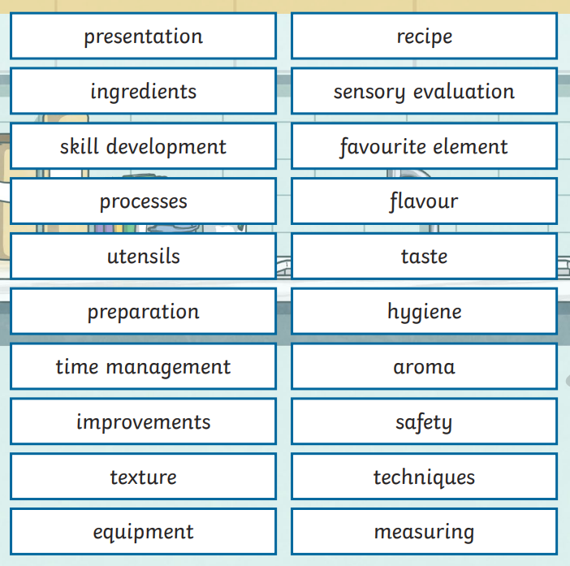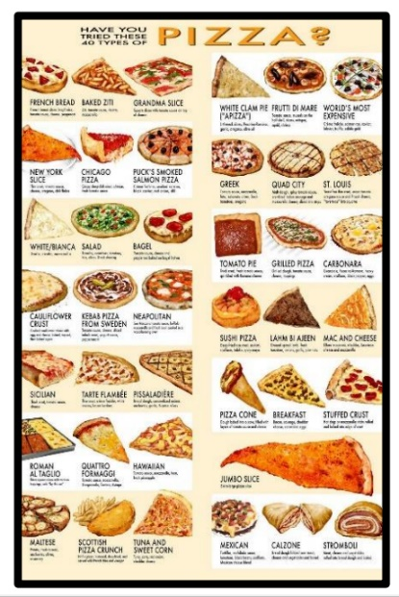Food Technology Knowledge Organiser**

**Key Knowledge**

Work with a partner with adult supervision to make own food product.

Weigh and measure ingredients with accuracy.

Confidently and independently, follow a recipe and make simple adaptations.

Use cutting techniques that require food to be cut up finely and in evenly sized pieces.

Understand the main food groups and that different nutrients are important for health.

Know appropriate portion sizes and the importance of not skipping meals, including breakfast.

Key Vocabulary