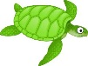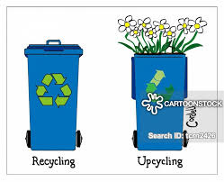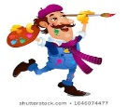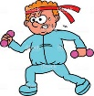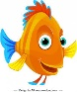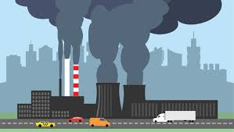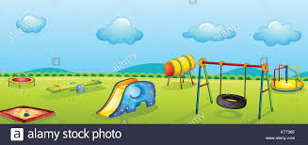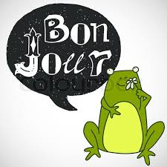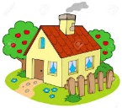

**Science**

The tiger, Amur leopard, orangutan, sea turtle and the Sumatran elephant are some of the most endangered animals on the planet. Choose an animal from one region and describe how it has evolved to suit its habitat. Now ask them to consider how their chosen animal may need to adapt due to the current environment and human threats it faces. Create an informative leaflet about the threat the animal faces and what humans can do to minimise these threats.

**D.T.**

Choose an item within the house that is not really used anymore - this could be an old item of clothing, an accessory or household item. Upcycle it to make a new item that you will use. Evaluate the product and identify any areas that you could improve if it was to be made again. You could even write a set of instructions so that other people can upcycle the same item too.

**Art**

Marine life faces a number of threats including plastic pollution, tourism, habitat destruction, ocean warming and overfishing. How can we make a difference now? Produce an image representing the impact society is having on today’s oceans using a medium of your choice. Now produce an image of an ideal ocean environment.

**History**

Air quality has been debated across the globe and many are concerned that pollution is making the quality of air poor in many countries. Some cities are now creating ‘Clean Air Zones’. With this in mind, create a set of questions that you could ask your parents, grandparents or other family members about how your local area has changed over time. Afterwards, you could interview your family members and then make a video news report about what you have discovered.

**Geography**

Imagine that a new park, housing development, restaurant or other structure is being built on green land near your home. How might this be positive for the environment? How might this be negative for the environment? Create a poster that explains the pros and cons of this new development. Consider wildlife, air and noise pollution and jobs.

**Our environment**

**M.F.L.**

Keep working on Duolingo – we are currently in second place.

**R.E.**

Think about how everyone has different lifestyles. Write about what makes your house a home.

**Music**

Compose a pattern of 4 beats repeated on a 4 by 4 grid. Find different objects in your house/garden that make a sound to perform it.

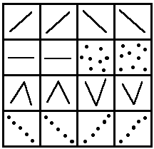

**Computing**

Research what makes the best environment for marine life to flourish (you may wish to direct them to the Great Barrier Reef and its significance). You could produce a Powerpoint of your findings. This will help with your art work.

**P.E.**

Do a Joe Wicks session. Design your own exercise routine – it must include 10 different exercises. We will try them out when we get back to school.