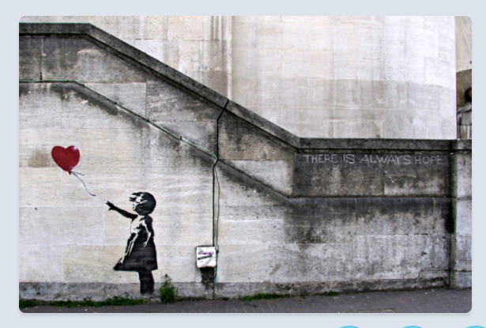Story starter
In a world where everything seemed black and white, it brought colour. In a world where things were often bleak, it brought joy.
The drawing of a girl’s outstretched fingers pointed at the red balloon as it floated skywards.
Many years ago a real girl had held a real balloon, releasing it into the sky as she hoped her dreams and prayers would be answered. Now, her image and memory were etched on the very walls behind the spot where she once stood.
Her story, and that of the red balloon, would be told for many generations to come…
Tell the story of the little girl and the red balloon.

