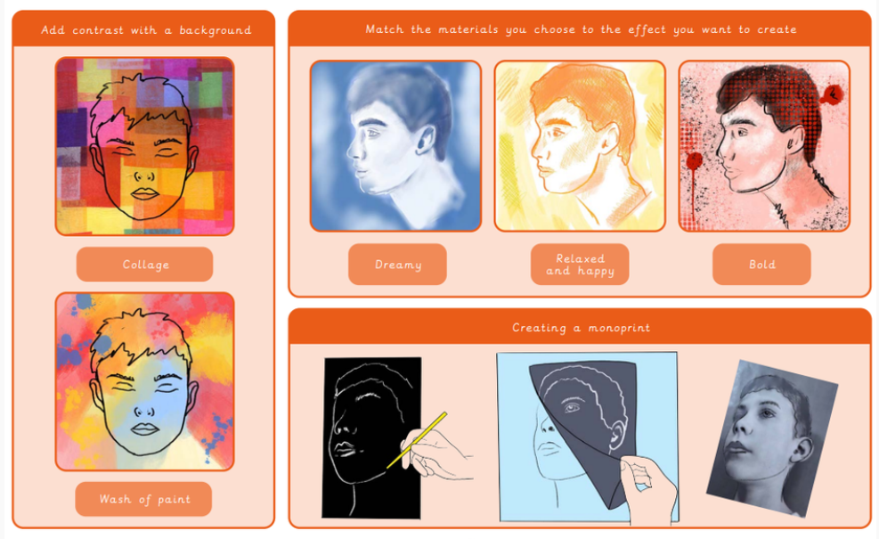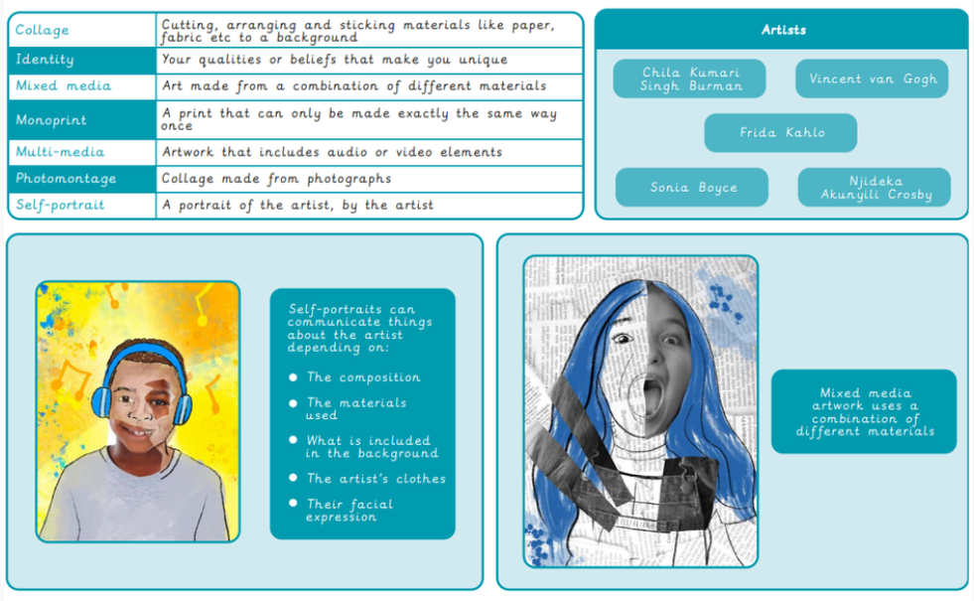

**Key Knowledge**

I can draw a portrait using the continuous line method.

I can vary the size, shape and position of the words for interest.

I can explore the way a background can change the effect of a drawing.

I can explain what I want my photo composition to be.

I can decide the best position for my line drawing when copying it onto the background.

I can use Art vocabulary to describe similarities and differences between portraits.

I can justify my opinion when discussing the message behind a self-portrait.

I can critically evaluate my work and refine if necessary.

**Key Vocabulary**

**Art and Design Knowledge Organiser Class 3**