**Animals including Humans Knowledge Organiser**

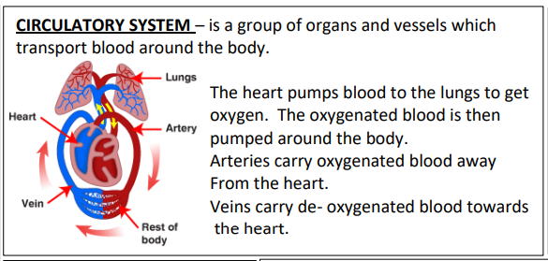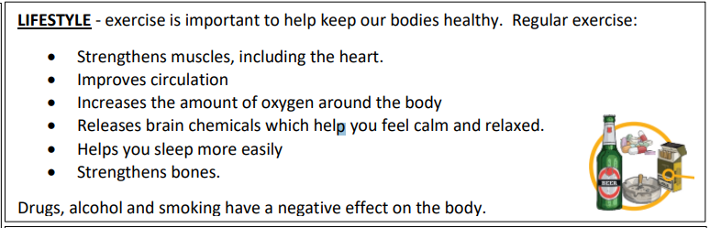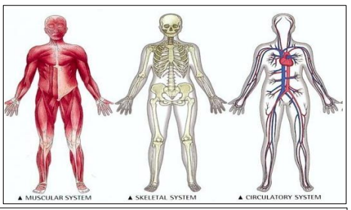

**Key Vocabulary**

**Circulatory System** – the parts of an animal’s body comprising the heart, veins, capillaries and arteries.

**Heart** – muscular organ that pumps blood through the body.

**Veins** – blood vessels that carry blood towards the heart.

**Artery** – blood vessels that deliver oxygen-rich blood from the heart to the tissues of the body.

**Oxygen** – a chemical element which animals need to survive.

**Blood vessels** – part of the circulatory system that carries blood (a vein, artery or capillary).

**Capillary** – very thin blood vessel. Nutrients – a source of nourishment that gives energy.

**Pulmonary** – relating to the lungs.

**Drug** - a substance containing natural or man-made chemicals that has an effect on your body when it enters your system.

**Alcohol** - a drug produced from grains, fruits or vegetables when they are put through a process called fermentation.

**Nutrients** - substances that animals need to stay alive and healthy.

**Key Knowledge**

* I have an understanding of the heart and the circulatory system.
* I can explain the importance of blood vessels and blood.
* I can explain the importance of exercise.
* I can explain how exercise affects the heart.
* I can explain why different people have different calorie requirements.
* I can explain the impact of drugs and alcohol on the circulatory system.

