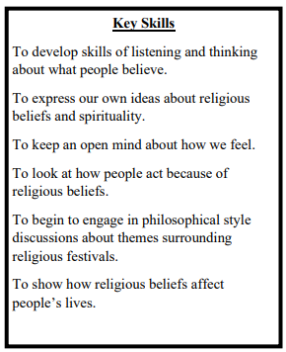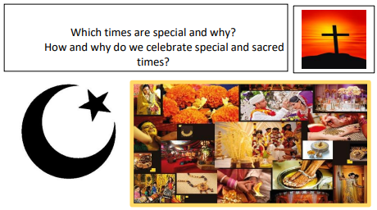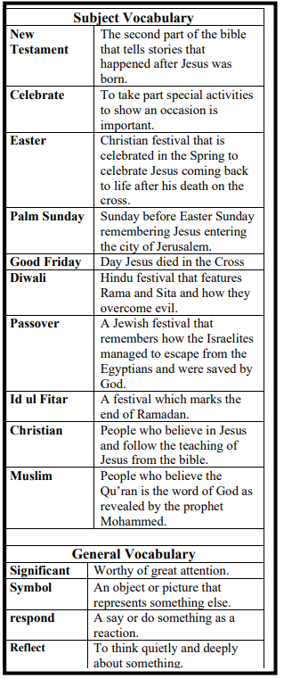

**Key Knowledge**

Knowledge of significant celebrations in their own lives and lives of others.

The stories and the meaning behind festivals celebrated by different faiths.

How festivals are marked or celebrated.

To know the similarities and difference between the festivals of different faiths.

To understand why these ancient festivals are still celebrated today.

**Key Knowledge will enable you to…**

Retell some stories behind festivals e.g. Christmas, Diwali, Eid al-Fitr (Id ul Fitar), Easter, Rosh Hashanah.

Make connections between stories, symbols and beliefs with what happens in at least two festivals.

Identify similarities and differences in the way festivals are celebrated within and between religions.

Discuss and present your own response about the role of festivals in the life of Britain today, showing your understanding of the values and beliefs at the heart of each festival studied, using a variety of media.

Explore and suggest ideas about what is worth celebrating and remembering in religious communities and in their own lives