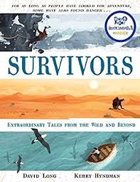
- Read from page 1, ‘The girl who fell from the sky,’ up to page 4, ‘…knew she had to start finding a way to safety.
- Predict how Koepcke will find her way to safety. You may choose how to present your thoughts e.g. you could do little pictures and captions, you could word process, you could write in paragraphs or you could come up with your own way.
- I have restrained myself from reading to the end so I can’t wait to see what you think will happen next!

