Learning Project Easter Holidays
Over the next couple of weeks try to have your Easter holiday. I have tried to give you fun things to do. Make sure you get time to do nice things with your family and don’t worry if you don’t do everything.
Ideas For Maths Tasks | Ideas For Reading and Writing Tasks
- Working on Times Table Rockstars - your child will have an individual login to access this (20 mins on SOUND CHECK).  - Play on Hit the Button - focus on number bonds, halves, doubles and times tables.  - Adding totals of the weekly shopping list or some work around money. This game could support work on adding money.  - Try the Easter Mystery Maths: The Mystery of the Easter Bunny Costume.  - Practise counting forwards and backwards from any given numbers in 100s.  - Do the Sumdog Maths Challenge! A National Competition starts on 3rd April. If we all do it we might get onto the leaderboard.  - Make an Easter Bunny cup cakes for your family.  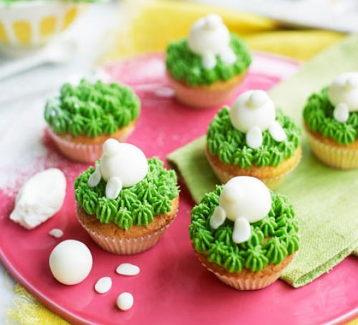  Practise reading scales by weighing the ingredients. You can discuss how the quantities will change if you needed to double/treble the quantities.  (The link for the recipe is on Class 2’s website) | - You could share a story together. This could be a chapter book where you read and discuss a chapter a day.  - Listen to your child read and let them discuss what they have read. Encourage them to read with expression and intonation.  - Watch Newsround and discuss what is happening in the wider world.  - Get your child to read a book on Oxford Owl, discuss what your child enjoyed about the book.  - With your child, look in magazines, newspapers and books for new vocabulary they are unfamiliar with. They could use a highlighter to highlight in magazines and newspapers.  - Write a letter to a family member telling them all about how their day has been.  - Write an Easter poem about all the things they like. Which adjectives and adverbs could they include too?  - If they were to become a superhero what would their superpower be? Write a character description of them as a superhero. Explain how they save the day.  - Retell a traditional tale from another character’s point of view. E.g Tell the three little pigs from the wolf’s perspective.  - Design an information leaflet that highlights how children can keep safe.  - Write out the recipe for your Easter cake.  - Do the Sumdog Reading and spelling challenge
Other ideas for you to do.
The project this week aims to provide opportunities for your child to learn more about different viewpoints. Learning may focus on physical viewpoints in terms of what you can see outside of the window at home, what others can see looking into your home and then progress onto personal viewpoints and of others.

- Time to wonder:
Look at the ‘Starter For STEM’ sheet (the link is on the website). There are lots of ideas for fun science at home. If you click on the links it takes you to videos and ideas for each activity.
- The Egg Drop!

One of our Easter traditions at North Stainley is to design and make a container that protects an egg when it is dropped from a height. We usually do it in the hall with the BIG ladders and the children love it! Your challenge is to make a structure/ container that protects an egg. Make sure your parents are with you and drop it out of your bedroom window! Go downstairs and see if your egg has survived! Please make sure your parent is with you when you do this activity as we don’t want anyone getting hurt! Upload your photos and show us how you get on.

- Be Active:
Move around their home and garden taking photographs from different viewpoints. Which photos do they like? Do the people they live with like the same photos as them? Why? Why not?
Recommendation at least 2 hours of exercise a week.

- Time to Talk:

Talk about keeping safe, discuss different ways to keep safe. Basic hygiene rules, road safety, internet safety, water safety, being safe around the home, stranger danger. How do different people view this?

- Understanding Others and Appreciating Differences:

Listen to different pieces of music from around the world, which styles of music do they prefer and why? Music Maybe they could learn a song by heart and perform it. You can have an on-line music lesson with Mrs Watkinson. Look at the menu on Class 2’s News Page.

- Reflect:

Design their own ideal world. Would their world contain the same things as other people? Which things are most important to them? What are they going to include?
Additional learning resources parents may wish to engage with
Classroom Secrets Learning Packs - These packs are split into different year groups and include activities linked to reading, writing, maths and practical ideas you can do around the home.
Twinkl - to access these resources click on the link and sign up using your own email address and creating your own password. Use the offer code UKTWINKLHELPS.
Headteacherchat - This is a blog that has links to various learning platforms. Lots of these are free to access.
#TheLearningProjects

