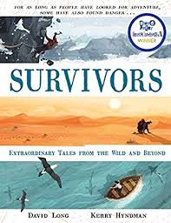
- Read P.103 from, ‘The ledge LeMarque was kneeling…’ up to P.105, ‘….weather finally cleared that he realised it.’
- How would you describe the situation Eric is in at this point?
- What facts show that Eric is in considerable danger?
- What motive did Eric have to go back up the mountain and start all over again?
- Based on what you know about Eric so far, can you describe him as a person?

