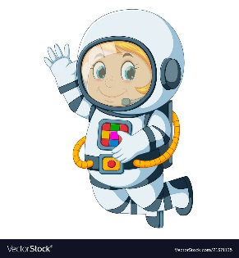
Astronaut Spellings
Week 2 27.9.21
poison
poisonous
danger
dangerous
peril
perilous
fame
famous
nerve
nervous

