Self Isolation Work
Week Beginning: 12/10/2020
Year Group: Reception

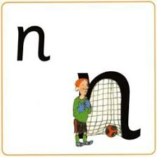
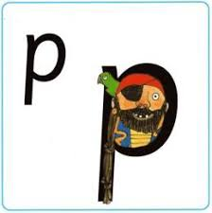
Phonics:
This weeks sounds: n and p
n: Up Nobby, down Nobby and over the net!
p: Up, down the plait, up to the parrot and around the pirates face!
Practise saying the rhyme, writing the letter in different ways- magic finger, in a bowl of rice, chalks, pens, tablet screen
Can you find things beginning with these letters?- draw them! Can you find these letters around the house, in your book, is this letter in your name?
Using the letters below, make some CVC words to practise Freddy Fingers!
m a s d t i n p
Maths:
This weeks mathematics focus: 1,2,3
Number blocks video: https://www.bbc.co.uk/iplayer/episode/b08bzh11/numberblocks-series-1-one-two-three
In class, we watch the video daily at the start of each session and then have a discussion about what they saw in the video!
Back on the page you downloaded this document there are resources to aid in this weeks learning!

Writing:
Can you draw the following things and label them:

M-u-m d-a-d d-o-g c-a-t p-i-n m-a-t l-e-g

