Maths Passports Explained
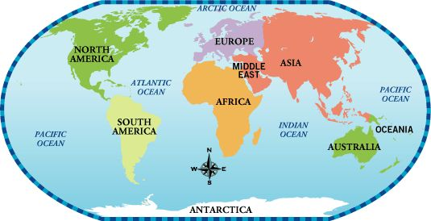

Firstly, your child will be in a certain continent. For example; Asia, South Africa, North America, Milkway.

Then, within each continent, the passport has a set amount of targets to achieve by rote/ with ease for mental maths before you can move up to the next continent. This is to aid the child’s fluency and recall of facts.

In order the achieve a target;

- Practise the target throughout the week. This might be verbal, written, watching videos or playing online games such as ‘hit the button’, sticking reminders up around the house or creating a poster, playing snap etc. This forms as part of weekly homework.
- Once feeling confident, practise doing a timed test:
  - If a sheet is provided: This means you get 45 seconds to answer the 10 questions in a column provided on the sheet. If you answer all the questions correctly within the time frame, you can then mark this off with the days date in the maths passport, to show it has been achieved once.
  - If there is no sheet provided: ask your child to complete the task verbally or on a piece of paper; ie. Count to 100- they can count verbally or write the numbers 0-100. If they show accuracy, confidence and understanding then you can then mark this off with the days date in the maths passport, to show it has been achieved once.
- Once your child has completed their target 3 times (and this has been marked off with 3 dates in their passport) then they will complete a final test- Tuesdays and Fridays we test/practise.
- If they manage to complete the target within 45 seconds, this target is then signed off (having been signed off 3 times and achieved in a final test) and they will move onto the next target. A sheet will be provided if the target has one.
Maths Passport Target Practise forms as part of the weekly homework, alongside reading and spelling practise.
The is no set ‘deadline’ or end point to the passports, the children will progress through the targets and subsequently the continents over the course of their time here at North Stainley. The children will achieve at their own pace and may find some targets trickier than others. Rigorous practise throughout the week is key to ensuring this information becomes embedded for quick recall.
Please ensure your child’s maths passport is in their bags Tuesdays and Fridays so we can mark off an achievement date or completed test date. The practise sheets can remain at home as the children have a duplicate copy to use in school.

