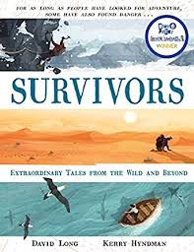
- Read from where we left off yesterday, page 4, ‘Koepcke had learned enough about the jungle…’ to the end. (Sorry if this is too much reading today – I just couldn’t stop!)
- Koepcke is 65 years old now. If you had the chance to interview her, what would you ask her?
- How do you think she would respond?

