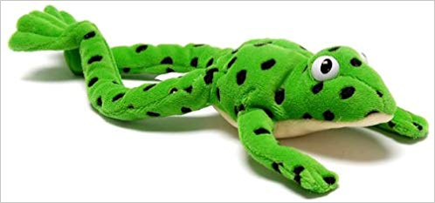
“Freddy Fingers”

In class we have started to orally blend sounds to start and read words. This involves breaking words down into their smallest units of sounds (phonemes).
With ReadWriteInc we use ‘Freddy Fingers’ as a teaching aid for reading, which corresponds to a puppet called Freddy Frog who can only speak in sounds, not whole words. Freddy teaches the children to use their fingers to break down words into their individual sounds to assist blending, reading and spelling. When children look at their own fingers, it allows them to visualise each sound of the word on a single finger.
For example:
a
t
m

m a t

- Count how many sounds and get that many fingers
- Working left to right, put each sound on a finger
- Say the sounds in order, faster and faster until you can hear the word!
So, above we can blend the three separate sounds m-a-t to make mat.
You can practise this at home using the sounds we have practised so far in class getting them to recognise and say the sounds (m a s d t i n p g o, c, k, u, b) and make words (sad, pin, mad, tim, sat, mat, dim, gap, pad, pig, pot, not, etc.). This bank of sounds will continue to increase over time.
You can then use this technique when your child is reading words in their reading books that are phonetically decodable to aid them in reading. You can use this to promote independence in reading and use it, when your child is confident and ready, for words with more than 3 sounds such as mast which would require 4 fingers etc.
(Youtube videos are also available by typing in “Ruth Miskin Fred Talk”)

