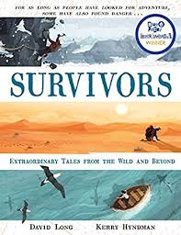
- Read from page 126, ‘He would have to be brought…’ to the end.
- Now watch this short clip.
https://www.bbc.co.uk/news/world-europe-27922781
- Imagine that you were one of the rescuers. When it was all over and you were home safely you would have told your family all about it.
- Write down what you would have told them.

