Art/Maths
Produce a piece of art work inspired by Andy Goldsworthy. Much of his work is underpinned with his knowledge of certain maths areas such as symmetry, shape, reflection and measuring. He was well known for producing work using anything to hand such as flowers, twigs, stones, mud and ice. For his tools, he uses hands, teeth and things found around him.
Have a look at this clip about him:

https://www.youtube.com/watch?v=f6i5cxbm6ac

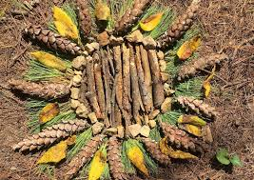

Of course, your environment at the moment will be completely different to his. However, use your imagination!

