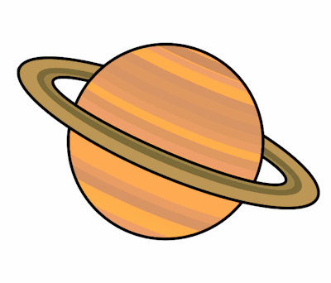
Planet Spellings
Week 3 18/1/22
Unit 14
extend
extension
expand
expansion
suspend
suspension
precise
precision
confuse
confusion

